

DATES IN FUTURE TO WATCH / FECHAS EN EL FUTURO PARA OBSERVAR
22 FEB 10:00 AM-12:00 PM QUIET MORNINGS IN LENT – CCCoP CORPUS
26 FEB 12:00 NOON STATIONS OF THE CROSS CORPUS
26 FEB 6:30 PM STATIONS OF THE CROSS ST LADS
26 FEB BEGINNING 7:00 PM YARNCRAFTERS’ RETREAT – CCCoP CORPUS
27 FEB 9:00 AM YOUTH GROUP MINI RETREAT – CHURCH/SCHOOL ST LADS
27 FEB 10:30 AM-12:00 PM CENTERING PRAYER – CCCoP CORPUS
28 FEB 9:00 AM CONCLUSION OF YOUTH GROUP MINI RETREAT ST LADS
28 FEB ENDING NOON YARNCRAFTERS’ RETREAT – CCCoP CORPUS
28 FEB 7:00 PM CHOIR PRACTICE – CHURCH ST LADS
29 FEB 10:00 AM-12:00 PM QUIET MORNINGS IN LENT – CCCoP CORPUS
4 MAR 12:00 NOON STATIONS OF THE CROSS CORPUS
4 MAR 6:30 PM STATIONS OF THE CROSS ST LADS
5 MAR 5:00 PM CARD PARTY – HUBER HALL ST LADS
6 MAR 1:00 PM ROSARY ALTAR SOCIETY MEETING CORPUS
6 MAR 7:00 PM CHOIR PRACTICE – CHURCH ST LADS
7 MAR 10:00 AM-12:00 PM QUIET MORNINGS IN LENT – CCCoP CORPUS

+++SCRIPTURES FOR CURRENT AND FOLLOWING WEEKENDS+++
+++SAGRADA ESCRITURA ESTE FIN DE SEMANA Y LOS PRÓXIMOS+++
21 February/febrero 28 February/febrero
1st): Genesis (Génesis) 15:5-12, 17-18 1st): Exodus (Éxodo) 3:1-8a, 13-15
RP): Psalm (Salmo 26) 27:1, 7-8, 8-9, 13-14 RP): Psalm (Salmo 102) 103:1-2, 3-4, 6-7, 8, 11
2nd): Philippians (Filipenses) 3:17-4:1 2nd): 1 Corinthians (1 Corintios) 10:1-6, 10-12
Gospel): Luke (Lucas) 9:28-36 Gospel): Luke (Lucas) 13:1-9

CATHOLIC TIMES SUBSCRIPTION INFORMATION
It’s Not Too Late! For $17.00 you will receive the Catholic Times. Use the envelope in your February packet, or write your name and “Catholic Times“ on a plain envelope. Make your check payable to our parish, and drop it into the collection basket.

ST. VINCENT de PAUL FOOD PANTRY
Please donate toilet paper for the month of February
DESPENSA DE COMIDA SAN VICENTE de PAUL
Por favor, done Papel higiénico para el mes de febrero
Statistics for the month of December 2015
Households served – 202 Clients served – 801 (9 meals per person)
Statistics for 2015
Households served – 2080 Clients served – 8186 (9 meals per person)

THE COLUMBUS FRASSATI SOCIETY AT ST. PATRICK'S CHURCH
For all young adults (age 21-34), the Columbus Frassati Society at St. Patrick's Church is hosting Christ in the City, an evening of prayer and fellowship. Contemplate the wellspring of Christ's love through a night of adoration and confession, concluded with Compline (Night Prayer). Feel free to join in singing the contemplative chants with us or to quietly gaze upon Our Lord during this time. We will go out for drinks afterward. The event will be held on Thursday February 25th at 7:00pm at St. Patrick's Church, 280 N. Grant Avenue.

STEWARDSHIP / ADMINISTRACIÓN
Offertory Collection February 13th/14th
Corpus Christi 42 envelopes $1,767.00
St. Ladislas 38 envelopes $1,766.00


YOUTH GROUP “SATURDAY NIGHT WITH JESUS”
The Corpus Christi and St. Ladislas’ Youth Group is conducting a sleep-over, mini-retreat February 27th and 28th. Parish youths, grades 8-12 are invited. Activities will begin at 9:00 a.m. Saturday, and end at 9:00 a.m. Sunday, in time for CGS attendance. The event will have adult supervision. Permission slips, signed by parents, are required.
Activities will include two praise and worship sessions, a blanket making craft project to support neighborhood needy families, fun activities, and an evening movie. The entire group will attend Mass at 4:00 p.m. Saturday. Saturday lunch and dinner, and breakfast Sunday morning will be served, compliments of adult volunteers from the parishes. Movie tickets and all other expense will be covered by the proceeds from the Discount Cards sold by the Youth Group Committee.
Youths in attendance will need a change of clothes, sleeping bags, pillows and toiletries and the permission form completed by parents. We may be driving to a local theatre for a movie to be determined. Attendees should have their own “popcorn” money. For more information, or to receive a copy of the permission form, please contact Karen Schlueb, Jennifer Hermann, Shirley Miller, Mike Gray 614-907-8873 or Jeff Adair 614-907-8909.
GRUPO DE JOVENES "SÁBADO POR LA NOCHE CON JESÚS"
Grupo de Jóvenes de Corpus Christi y San Ladislao 'está llevando a cabo un mini retiro de febrero 27 y 28 sobre el sueño. Los Jóvenes de la parroquia, invitan a los grados 8-12. Las actividades comenzarán a las 09 a.m. del sábado, y finalizará a las 09 a.m. domingo, a tiempo para la asistencia CGS. El evento tendrá supervisión de un adulto. Las hojas de permiso, firmado por los padres, se requieren.
Las actividades incluirán dos sesiones de alabanza y adoración, un proyecto de fabricación artesanal manta para apoyar a las familias necesitadas del barrio, actividades divertidas, y una película en la noche. Todo el grupo asistirá a la misa de las 4:00 p.m. el sábado. Sábado almuerzo y la cena y el desayuno por la mañana del domingo serán servidos, cortesía de adultos voluntarios de las parroquias. Entradas de cine y otros gastos derivados serán cubiertos por los ingresos de las tarjetas de descuento vendidos por el Comité del Grupo de Jóvenes.
Los jóvenes que asistan necesitaran un cambio de ropa, sacos de dormir, almohadas y artículos de higiene personal y la forma de permiso completado por los padres. Podemos estar conduciendo a un teatro local para una película que se determine. Los asistentes deben tener su propio dinero "palomitas de maíz". Para obtener más información, o para recibir una copia del formulario de permiso, por favor, póngase en contacto con Karen Schlueb, Jennifer Hermann, Shirley Miller, Mike Gray 614-907-8873 o Jeff Adair 614-907-8909.

OPEN HOUSE AT OUR LADY OF BETHLEHEM SCHOOL AND CHILDCARE
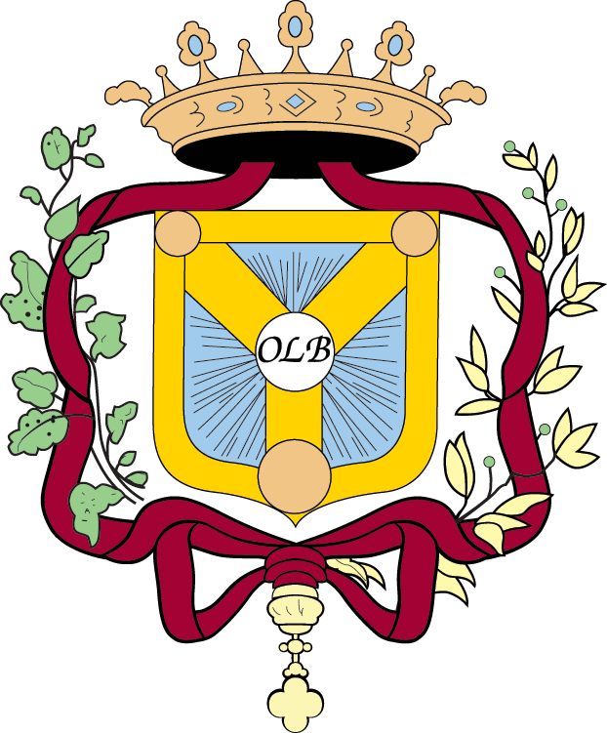
On Sunday, March 6th from 1:00-3:00 p.m. there will be Open House. In the tradition of the Sisters of the Poor Child Jesus, Our Lady of Bethlehem is a comprehensive Catholic school and childcare whose mission is to provide exceptional faith formation and early education in a safe, nurturing community to each student and family it serves. Open Enrollment for school and summer program is going on now! Bring in this bulletin and receive 10% off your registration fee!

AH, THE KNOTS OF OUR LIVES! A WEEKEND RETREAT FOR YARNCRAFTERS
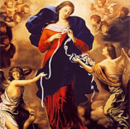
Beginning February 26th through 28th, Corpus Christi Center of Peace will host a weekend retreat for yarncrafters. Knots. Call them what you will, we all have them: difficulties in our lives. However, God never leaves us without divine assistance. In response to the original knot of sin tied by Eve in the Garden, God has lovingly given us Our Lady, Undoer of Knots – a special devotion of Pope Francis. This Yarncrafters’ Retreat will provide opportunities for us to undo knots in our lives with Mary as we “knot” creatively for ourselves and others. Bring your knitting, crocheting, tatting, embroidery project(s). For information or to register, go online cccenterofpeace.org, email corpuschristicenterofpeace@gmail.com or phone 614-512-3731.

MOVIE SERIES CONTINUES AT CORPUS CHRISTI CENTER OF PEACE
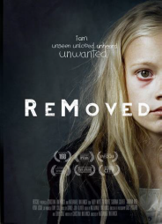
Continuing the Film Series, Movies that Touch Our Hearts, on Thursday, March 10th at 6:30 p.m. Corpus Christi Center of Peace will be showing "ReMoved". This film follows a 10-year-old girl as she navigates her way through the foster care system, after being removed from her home and separated from her younger brother. Described as being one of the most realistic portrayals of the challenges faced by all who are involved in the foster care system, the film is used by social service agencies as a tool for training case workers who work with children, their families and foster parents. We’ll be joined this evening by a case worker for Buckeye Ranch and another adult who will share with us from personal experience what it’s like to grow up in the foster system. Please register online at cccenterofpeace.org to reserve a bowl of popcorn and your seat for this powerful film! Call or email us at 614-512-3731 or corpuschristicenterofpeace@gmail.com.

RETREAT DAY JOURNALING THE JOURNEY WITH MARY VAN BALEN

On Saturday, March 19th, from 9:00 am - 4:30 pm Corpus Christi Center of Peace will be hosting a retreat day, Journaling The Journey: A Day Of Writing Into Prayer with Mary Van Balen. The $25.00 cost includes lunch and coffee breaks. Though we each encounter God in the present, being attentive to the moment is difficult. During this workshop/retreat, Mary will engage you in a variety of journaling experiences that will help unlock the writer within as well as encourage you to find new ways to be present to the moment and open to the Divine Relationship that is offered in it. Begin the new year with a gift for yourself, or someone you love. Register online at cccenterofpeace.org or by email: corpuschristicenterofpeace@gmail.com. Call 614-512-3731 for more information.

FROM THE DIOCESAN OFFICE FOR SOCIAL CONCERNS
40 Days for Life FEBRUARY 10TH TO MARCH 20TH
The Greater Columbus community will be uniting with hundreds from all 50 states in the 40 Days for Life campaign. Faithful believers are praying that this effort will mark the beginning of the end of abortion in America. This peaceful prayer vigil will take place at an abortion facility in Columbus. Participants are asked to volunteer for one-hour shifts and sign a statement of peace. For details, visit www.40daysforlife.com/columbus.

MARCH IS DEVELOPMENTAL DISABILITIES MONTH
The National Catholic Partnership on Disability (NCPD) facilitates the implementation of the Pastoral Statement of U.S. Catholic Bishops on People with Disabilities by calling for inclusion of people with disabilities in the life of the Church and society. Many of NCPD’s resources can be found online at www.ncpd.org.

RESPECT LIFE CONFERENCE
The Diocesan Respect Life Conference is Saturday, March 5th, at St. Joseph Church, Plain City. The theme is Being Pro-Life in the Year of Mercy. The keynote speaker is Fr. Kevin Lutz. Other speakers will cover the spectrum of care and concern promoting the dignity of human life. The conference runs 10:00 a.m. to 3:00 p.m. Registration is $20.00, which includes lunch. To register, send a check payable to the Office for Social Concerns, 197 E. Gay St., Columbus, 43215. For details, call 614-241-2540 or email socmailbox@colsdioc.org.

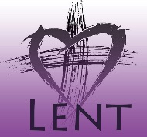
WHAT ARE YOU DOING FOR LENT DURING THIS JUBILEE YEAR OF MERCY?
Pope Francis is asking that during this Jubilee Year, the season of Lent should be “lived more intensely as a privileged moment to celebrate and experience God’s mercy.” He is calling us to immerse ourselves so deeply in the mercy of God that we will undergo a profound spiritual conversion. How will you use the forty days of Lent to journey to a deeper understanding of God’s mercy? How will your life be changed? How will you reach out to others? How will others offer mercy to you?
In the bulletin, each week of Lent will offer new suggestions to help you experience a spiritual conversion.
Deepen Your Love Pope Francis tells us that the real meaning of love can never by selfish or superficial and that love, by its very nature, is something “concrete: intentions, attitudes, and behaviors that are shown in daily living.” Every morning during Lent, remind yourself that you are called to love God and to love your neighbor. Every evening examine your conscience in the light of how loving you were throughout the day.
¿QUÉ ESTÁS HACIENDO PARA LA CUARESMA DURANTE EL JUBILEO AÑO DE MISERICORDIA?
Francisco está pidiendo que durante este año jubilar, el tiempo de Cuaresma debe ser "vivido más intensamente como un momento privilegiado para celebrar y experimentar la misericordia de Dios." Él nos ha llamado a sumergirse tan profundamente en la misericordia de Dios que vamos a sufrir una profunda conversión espiritual. ¿Cómo va a utilizar los cuarenta días de la Cuaresma viajando a una comprensión más profunda de la misericordia de Dios? ¿Cómo puede cambiar su vida? ¿Cómo va a llegar a los demás? ¿Cómo van a ofrecer otra misericordia a usted? En el boletín, cada semana de Cuaresma ofrecerá nuevas sugerencias para ayudarle a experimentar una conversión espiritual.
Profundizar Su Amor Francisco nos dice que el verdadero significado del amor nunca puede por contienda osuperficial y que el amor, por su propia naturaleza, es algo "concreto:. Intenciones, actitudes y comportamientos que se muestran en la vida diaria" Todas las mañanas durante la Cuaresma, recuerdan a sí mismo que están llamados a amar a Dios y amar al prójimo. Todas las noches has un examen de conciencia a la luz de lo amoroso que fuiste a lo largo del día.

CATHOLIC MEN'S LUNCHEON CLUB EVENT FRIDAY, MARCH 4th
The next Catholic Men’s Luncheon Club session will feature Father Michael Mary Dosch, O.P., pastor of St. Patrick church in Columbus. His talk will be on “Mercy and Justice”. This event will take place at St. Patrick Church in downtown Columbus. Holy Mass begins at 11:45 am followed by lunch and Fr. Dosch’s talk until 1:00 pm. No reservations necessary. $10.00 covers the lunch and meeting. Bring a friend! For information on Catholic Men’s Luncheons, contact Tim Merkle, CMLC President at htm@ejhlaw.com.

BE HUMBLE
Life is not about honor and prestige; it is about becoming a servant to others, about humility in all you do because everything you are and the talents you have received have been given to you as a gift. — from Geekpriest

