

DATES IN FUTURE TO WATCH / FECHAS EN EL FUTURO PARA OBSERVAR
9 OCT 9:00-10:30 AM CATECHESIS OF THE GOOD SHEPHERD BEGINS – ATRIA LADS
9 OCT 2:00 PM SENIOR STARS – SHOTT HALL LADS
13 OCT SENIOR STARS SHRINE AT CAREY BUS TRIP – MEET LADS
16 OCT 12:30-3:30PM CC/SL JOINT PARISH PICNIC – HUBER HALL LADS
18 OCT 7:00 PM PASTORAL COUNCIL MEETING – SHOTT HALL LADS

+++SCRIPTURES FOR CURRENT AND FOLLOWING WEEKENDS+++
+++SAGRADA ESCRITURA ESTE FIN DE SEMANA Y LOS PRÓXIMOS+++
9 October/octubre 16 October/octubre
1st): 2 Kings (2 Reyes) 5:14-17 1st): Exodus (Éxodo) 17:8-13
RP): Psalm (Salmo 97) 98:1, 2-3, 3-4 RP): Psalm (Salmo 120) 121:1-2, 3-4, 5-6, 7-8
2nd): 2 Timothy (2 Timoteo) 2:8-13 2nd): 2 Timothy (2 Timoteo) 3:14—4:2
Gospel): Luke (Lucas) 17: 11-19 Gospel): Luke (Lucas) 18:1-8
STEWARDSHIP / ADMINISTRACIÓN
October 1st/2nd Offertory Collection
CC 45 env. $1954.00 SL 37 env. $2,541.00


OUR JOINT PARISH GATHERING
is next weekend on Sunday, October 16th from 12:30-3:30 p.m. It will be held at St. Ladislas in Huber Hall. Meat and beverages will be provided, and each family is asked to bring a side dish (last name A – M) or dessert (last name N – Z). Please RSVP to attend, help set up/take down using the sign-up sheets at each church. There will be bingo and children's games available. Your donations of bingo prizes are needed and appreciated. Please place prizes in designated boxes at each church.
NUESTRA REUNIÓN PARROQUIA CONJUNTA
es el domingo 16 de de octubre de de 12: 30-3: 30 pm Se llevará a cabo en el St. Ladislao en Huber Hall. Se proporcionarán la carne y bebidas, y se le pide a cada familia para llevar un plato lateral (apellido A - H) o un postre (apellidos N - Z). Por favor confirmar su asistencia a asistir, ayudar a establecer / a acabar usando las hojas de inscripción en cada iglesia. Habrá bingo y juegos para los niños. Su donación de premios de bingo son necesarios y apreciados. Coloque premios en cajas designadas en cada iglesia.
CORPUS CHRISTI CHOIR/CORPUS CHRISTI CORO
Saint Augustine tells us "He who sings prays twice". The Corpus Christi choir is always looking for new members to join us in making music for the Lord. The only requirement is a love for singing. No prior experience or music training is necessary. We practice most Thursday evenings at 6:00 pm for one hour. Please see our organist Tom Dailey or any choir member if you are interested.
San Agustín nos dice: "El que canta ora dos veces". El coro Corpus Christi siempre está buscando nuevos miembros a unirse a nosotros para hacer música para el Señor. El único requisito es un amor por el canto. Sin experiencia o la música entrenamiento previo es necesario. Practicamos la mayoría de los jueves por la noche a las 6:00 pm durante una hora. Por favor, vea nuestra organista Tom Dailey o cualquier miembro del coro si está interesado.

SUPPORT COLUMBUS RIGHT TO LIFE AND THE KNIGHTS OF COLUMBUS
The Columbus Right to Life and Knights of Columbus Entertainment Books are available again this year. The cost per book is $30.00. To place your order or for more information, please call Mary Burkey at 614-829-6827 or Carolyn Lenihan at 614-497-1633. These books make great gifts and will be available now through December 17th. Thank you for your support.
ST. VINCENT de PAUL FOOD PANTRY
Please donate cereal for the month of October
DESPENSA DE COMIDA SAN VICENTE de PAUL
Por favor, done cereal para el mes de octubre
Statistics for the month of September 2016
Households served – 150 Clients served – 506 (9 meals per person)
Statistics for 2015
Households served – 2080 Clients served – 8186 (9 meals per person)

OCTOBER RESPECT LIFE MONTH BABY BOTTLE CAMPAIGN


In 2015, PDHC served 4,169 women at their greatest time of need. We were able to do this because of your generous support. You are helping to relieve financial and emotional burdens from women facing difficult situations. All of PDHC’s services are free and confidential, including pregnancy testing, ultrasound, consultation, parenting classes, abortion recovery services, and much more. If you didn’t pick up your empty baby bottle last week, pick one up today, fill it with coins, cash, or a check and return it to the church by Sunday, October 30th.
OCTUBRE RESPETO A LA VIDA MESES BEBÉ BOTELLA DE CAMPAÑA
En 2015, sirvió PDHC 4.169 mujeres en su mayor momento de necesidad. Hemos sido capaces de hacer esto debido a su apoyo generoso. Usted está ayudando a aliviar la carga financiera y emocional de las mujeres que enfrentan situaciones difíciles. Todos los servicios de PDHC son gratuitos y confidenciales, incluyendo pruebas de embarazo, ultrasonido, consultas, clases para padres, servicios de recuperación de aborto, y mucho más. Si no recoge su biberón vacío la semana pasada, coger uno hoy, llenarlo con monedas, dinero en efectivo o un cheque y devolverlo a la iglesia el domingo, 30 de octubre.


STRENGTHENING THE HOUSEHOLD OF FAITH
Jesus asks us to demonstrate our love for Him through our generosity to others. In our everyday lives, He calls us to share our gifts of time, talent and treasure with others. “While we have the opportunity, let us do good to all people - but especially to those of the household of the faith.” (Galatians 6:10)
Corpus Christi and St. Ladislas parishes have established an endowment fund at The Catholic Foundation to help strengthen our household of faith. Your gifts of cash, stock, real estate and insurance are needed to make our endowment grow, giving our parish perpetual income. For more information, call The Catholic Foundation at 614-443-8893 or visit catholic-foundation.org.

BETHESDA HEALING MINISTRY
God still heals today! Do we think that His miracles of healing were for another time in history? Every time our Bethesda program meets with the people who participate with varied situations and circumstances, we leave the evening KNOWING without a doubt that His mercy was in and with us. Each person has had an abortion experience with an unique story, but He does not hold back His healing. Right there our gentle Shepherd provides a priest for confession, a companion who knows the pain and evidences new grace and peace. Please come. He is waiting for you. Bethesda Healing Ministry sessions occur on the 2nd and 4th Mondays of each month. We will be meeting next on Monday, October 10th. Please call Bethesda Healing Ministry confidential lines: 614-309-2651 or 614-309-0157 or visit our website at bethesdahealing.org. Be sure to "Like" us on Facebook at www.facebook.com/BethesdaHealing

5TH ANNUAL SACRED HEART CONGRESS SATURDAY OCTOBER 15th
Registration is now open for the 2016 Sacred Heart Congress hosted at St. Matthew Church in Gahanna. The October 15th free event begins at 8:00 a.m. and ends with Mass at 11:30 a.m. The speakers include Dr. Timothy O'Donnell, Fr. Stash Dailey and Fr. Ted Sill. To register call Doug Smith at 614-371-2595 or go to www.SacredHeartColumbus.org. Light refreshments will be provided.

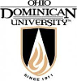
OHIO DOMINICAN UNIVERSITY OPEN HOUSE
Ohio Dominican University will host an undergraduate open house at 9:00 a.m. on Saturday, October 15th, on its main campus at 1216 Sunbury Road, Columbus. This is a great opportunity for students to talk with a professor, learn about ODU’s admission process, take a tour of campus and explore ODU’s 40 in-demand majors. To register, please visit ohiodominican.edu/OpenHouse.

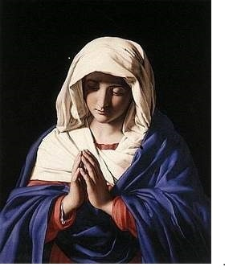
ROSARY RALLY FOR OUR NATION
Please join us in praying for our nation on Saturday, October 15th, at 12:00 noon. People will gather in public prayer in cities across the nation. Together, we will be asking God through the Rosary of His Most Holy Mother to save America. Our local Public Square Rosary Rally will take place on the grounds of Our Lady of Peace Church (E. Dominion and N. High Street). Call Rosalinda, 614-560-4523, for more information.

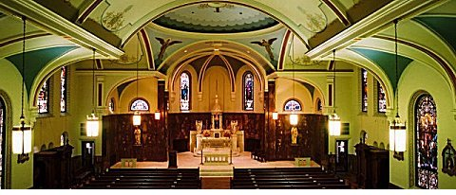
MARIAN CONCERT AT SAINT LEO CHURCH
There will be a Marian Concert at Saint Leo Church, 221 Hanford, Sunday, October 16th at 6:30 PM. Please come to the 4th Biennial Marian Concert for an evening of song, short meditations and prayer dedicated to Our Lady of Lourdes in this Year of Divine Mercy. St Mary’s three choirs (Handbell, Contemporary, Combined choruses St. Mary Traditional Choir and the Mendelssohn Liedertafel), Holy Family Choir, The Catholic Polish Community, Catholic Korean Community, and St. Patrick Church Choir and soloist, Cecile Smith will be performing. Between choirs, Fr. Nicholas Droll will lead meditations on Mary, Our Lady of Lourdes. We will begin the evening by crowning Mary. At the end, you may put your written petitions into a basket which we will burn later that evening. Please join us with your family and friends and pray for Peace in our World! Any donations made that evening will go to the St. Leo Seminarian Endowment Fund and the Preservation Society.

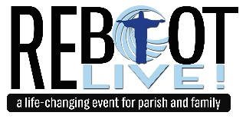
REBOOT! LIVE! REDISCOVER THE LIFE GOD CREATED FOR YOU
On Thursday, November 17th from 7:00 until 9:30 p.m. St. Peter Catholic Church, 6899 Smoky Row Road, will be hosting national speaker Chris Stefanick, founder of Real Life Catholic, for Reboot! Live! This gathering is a fun, inspiring, and practical experience of applying the beauty and genius of the Gospel to every aspect of your life – prayer, spirituality, work, dating, marriage, parenting, health, and more! No part of your life will be untouched. This is a multi-generational event for ages 12 and older. We invite you to bring your family, friends, neighbors and co-workers – Catholics and non-Catholics alike. Cost is $19.00 per ticket. For Tickets Online: http://reallifecatholic.com/reboot-live-participants/or contact Holly at: 614.889.2221 ext. 104. Deadline for Tickets: October 17th.

THE RED WAGON EVENT TO CHALLENGE POVERTY
Is sponsored by the Christ Child Society of Columbus. It will be on Wednesday, October 19th, at Villa Milano beginning at 10:30 am. Red Wagon Fare features a luncheon, a shopping boutique, and a style show. Proceeds from the event go to support projects for at-risk infants and children in the Columbus area. Christ Child Society members are dedicated to making a difference in the lives of these children and work to “challenge poverty – one child at a time.” Celebrating its 35th year, Christ Child Society of Columbus volunteers donate over 10,000 hours each year through outreach programs that include providing baby layettes, books, and parenting information to over 1700 infants and their parents; child care tuition assistance and pre-school learning programs; infant supplies to women attending parenting classes; hot meals for over 100 children weekly after school; tutoring and scholarships. Christ Child members choose to work on projects that interest them and that fit in with their schedules. Please consider joining the Christ Child Society. Tickets for the luncheon are available at the Christ Child Society of Columbus website www.christchildsociety.org or by contacting any Christ Child member.

YEAR OF MERCY SERIES AT ST. MARY MAGDALENE CHURCH
There are two remaining presentations. All are welcome.
Monday, October 21st – 9:00 a.m. - Lisa Keita of J.O.I.N. - feeding/clothing the poor
Saturday, December 3rd – 10:00 a.m. - Kambra Malone of Back in His Arms Again - burying the dead.
Sponsored by St. Mary Magdalene, Office for Social Concerns, and the Catholic Foundation.

CRAFTYPALOOZA/ CRAFTYPALOOZA
Please join us on Saturday, October 22nd from 9:00 a.m. until 3:00 p.m. for Craftypalooza at St Timothy School, 1070 Thomas Lane, Columbus. 80 booths featuring local vendors of unique handmade items: Jewelry, clothing & accessories, woodcrafts, holiday items, crocheted items, home décor and much, much more! Wonderful raffle prizes, concessions and delicious baked goods! All proceeds from booth rentals, raffle sales and concessions benefit St Timothy School. Please spread the word and come shop for some great items! Questions? Contact sttim.craftypalooza@gmail.com
Por favor, únase a nosotros el sábado, 22 de de octubre de de 9:00 am hasta las 3:00 p.m. durante Craftypalooza en la Escuela de San Timoteo, 1070 Thomas Lane, Columbus. 80 cabinas que ofrecen los proveedores locales de artículos hechos a mano únicos: joyería, ropa y accesorios, Trabajos en madera, artículos de fiesta, artículos de punto, decoración para el hogar y mucho, mucho más! maravillosos premios de la rifa, concesiones y deliciosos productos horneados! Todos los ingresos de alquileres de la cabina, las ventas de la rifa y concesiones se benefician Escuela de San Timoteo. Pasa la voz y venir tienda para algunos grandes artículos! ¿Preguntas? Póngase en contacto con sttim.craftypalooza@gmail.com

WELCOME TO THE LIGHT OF GOD’S MERCY
A Prayerful Celebration of Reconnecting and Renewal in the Spirit of St. Mother Teresa
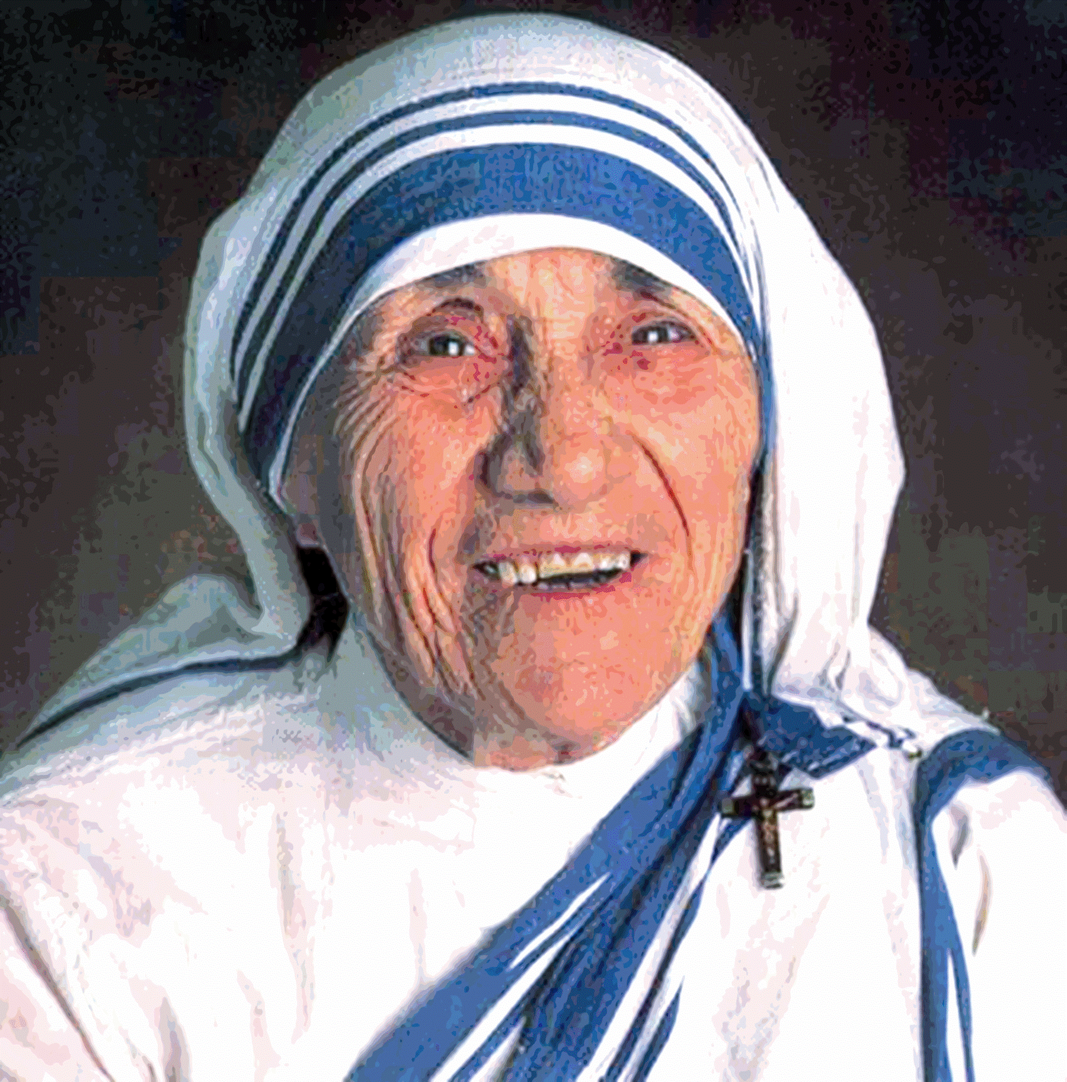
In the spirit of the Year of Mercy, everyone is invited to come to a joyful celebration of God’s embrace of all. Please join with others on Sunday, October 23rd at 7:00 p.m. at St. Paul the Apostle Church, 313 N. State St., Westerville.

CLASSES TO OFFICIATE DIOCESAN YOUTH BASKETBALL
Classes to officiate basketball, including eligibility to officiate diocesan youth games, will be held at St. Mary Magdalene Parish, 2909 Parkside Road, beginning Monday, October 24th, at 6:00 p.m. The class cost is $125.00. Enroll online at www.ohsaa.org. For additional details, contact Julius Palazzo at 614-276-9373 or jmpalazzo@juno.com.

