SUNDAY BIBLE STUDY
The King’s Authority
Readings:
Deuteronomy 18:15-20
Psalm 95:1-2, 6-9
1 Corinthians 7:32-35
Mark 1:21-28
Last week, Jesus announced the kingdom of God is at hand. This week, in mighty words and deeds, He exercises His dominion - asserting royal authority over the ruler of this world, Satan (see John 12:31). Notice that today’s events take place on the sabbath. The sabbath was to be an everlasting sign -both of God’s covenant love for His creation (see Exodus 20:8-11; 31:12-17), and His deliverance of his covenant people, Israel, from slavery (see Deuteronomy 6:12-15). On this sabbath, Jesus signals a new creation - that the Holy One has come to purify His people and deliver the world from evil. “With an unclean spirit” is biblical language for a man possessed by a demon, Satan being the prince of demons (see Mark 3:22). The demons’ question: “What have you to do with us?” is often used in Old Testament scenes of combat and judgment (see Judges 11:12; 1 Kings 17:18). And as God by His word “rebuked” the forces of chaos in creating the world (see Psalms 104:7; Job 26:10-12), and again rebuked the Red Sea so the Israelites could make their exodus (see Psalm 106:9), Mark uses the same word to describe Jesus rebuking the demons (see Mark 4:39; Zechariah 3:2). Jesus is the prophet foretold by Moses in today’s First Reading (see Acts 3:22). Though He has authority over heaven and earth (see Daniel 7:14,27; Revelation 12:10), He becomes one of our own kinsmen. He comes to rebuke the forces of evil and chaos - not only in the world, but in our lives. He wants to make us holy in body and spirit, as Paul says in today’s Epistle (see Exodus 31:12). In this liturgy, we hear His voice and “see” His works, as we sing in today’s Psalm. And as Moses tells us today, we should listen to Him. –The St. Paul Center for Biblical Theology
St. Anthony “Wish List”
☺ Parking lot repaired and resurfaced
☺ Air conditioners replaced for Church & Rectory
☺Kitchen & Parish Hall refurbished
We thank all of you that have helped us accomplish our list so far!
☺☺☺☺☺☺☺

2nd Collections for
February
Feb. 16- Local STVDP
Feb. 22- Black & Indian Missions

Continuing Education
Adult Education classes have resumed on Sundays at 9:30am in the parish hall downstairs.
CCD- Began Sept. 21st in Tony’s Place from 9:15 – 10:30
RCIA- Please see Father John for instructions

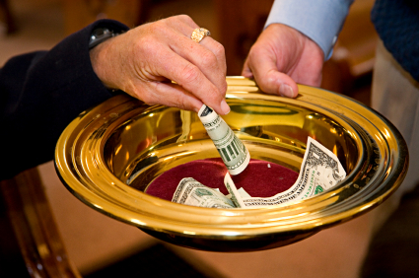
Last week’s Collections
01-24-15 Offertory $ 1501.00
Hisp. Ministries $ 43.00
01-25-15 Offertory $ 1008.00
Hisp. Ministries $ 101.00
We thank you for your continued support of our parish! If you missed a prior collection, you may drop your envelope in the next collection. We are so grateful for our wonderful parishioners and visitors!

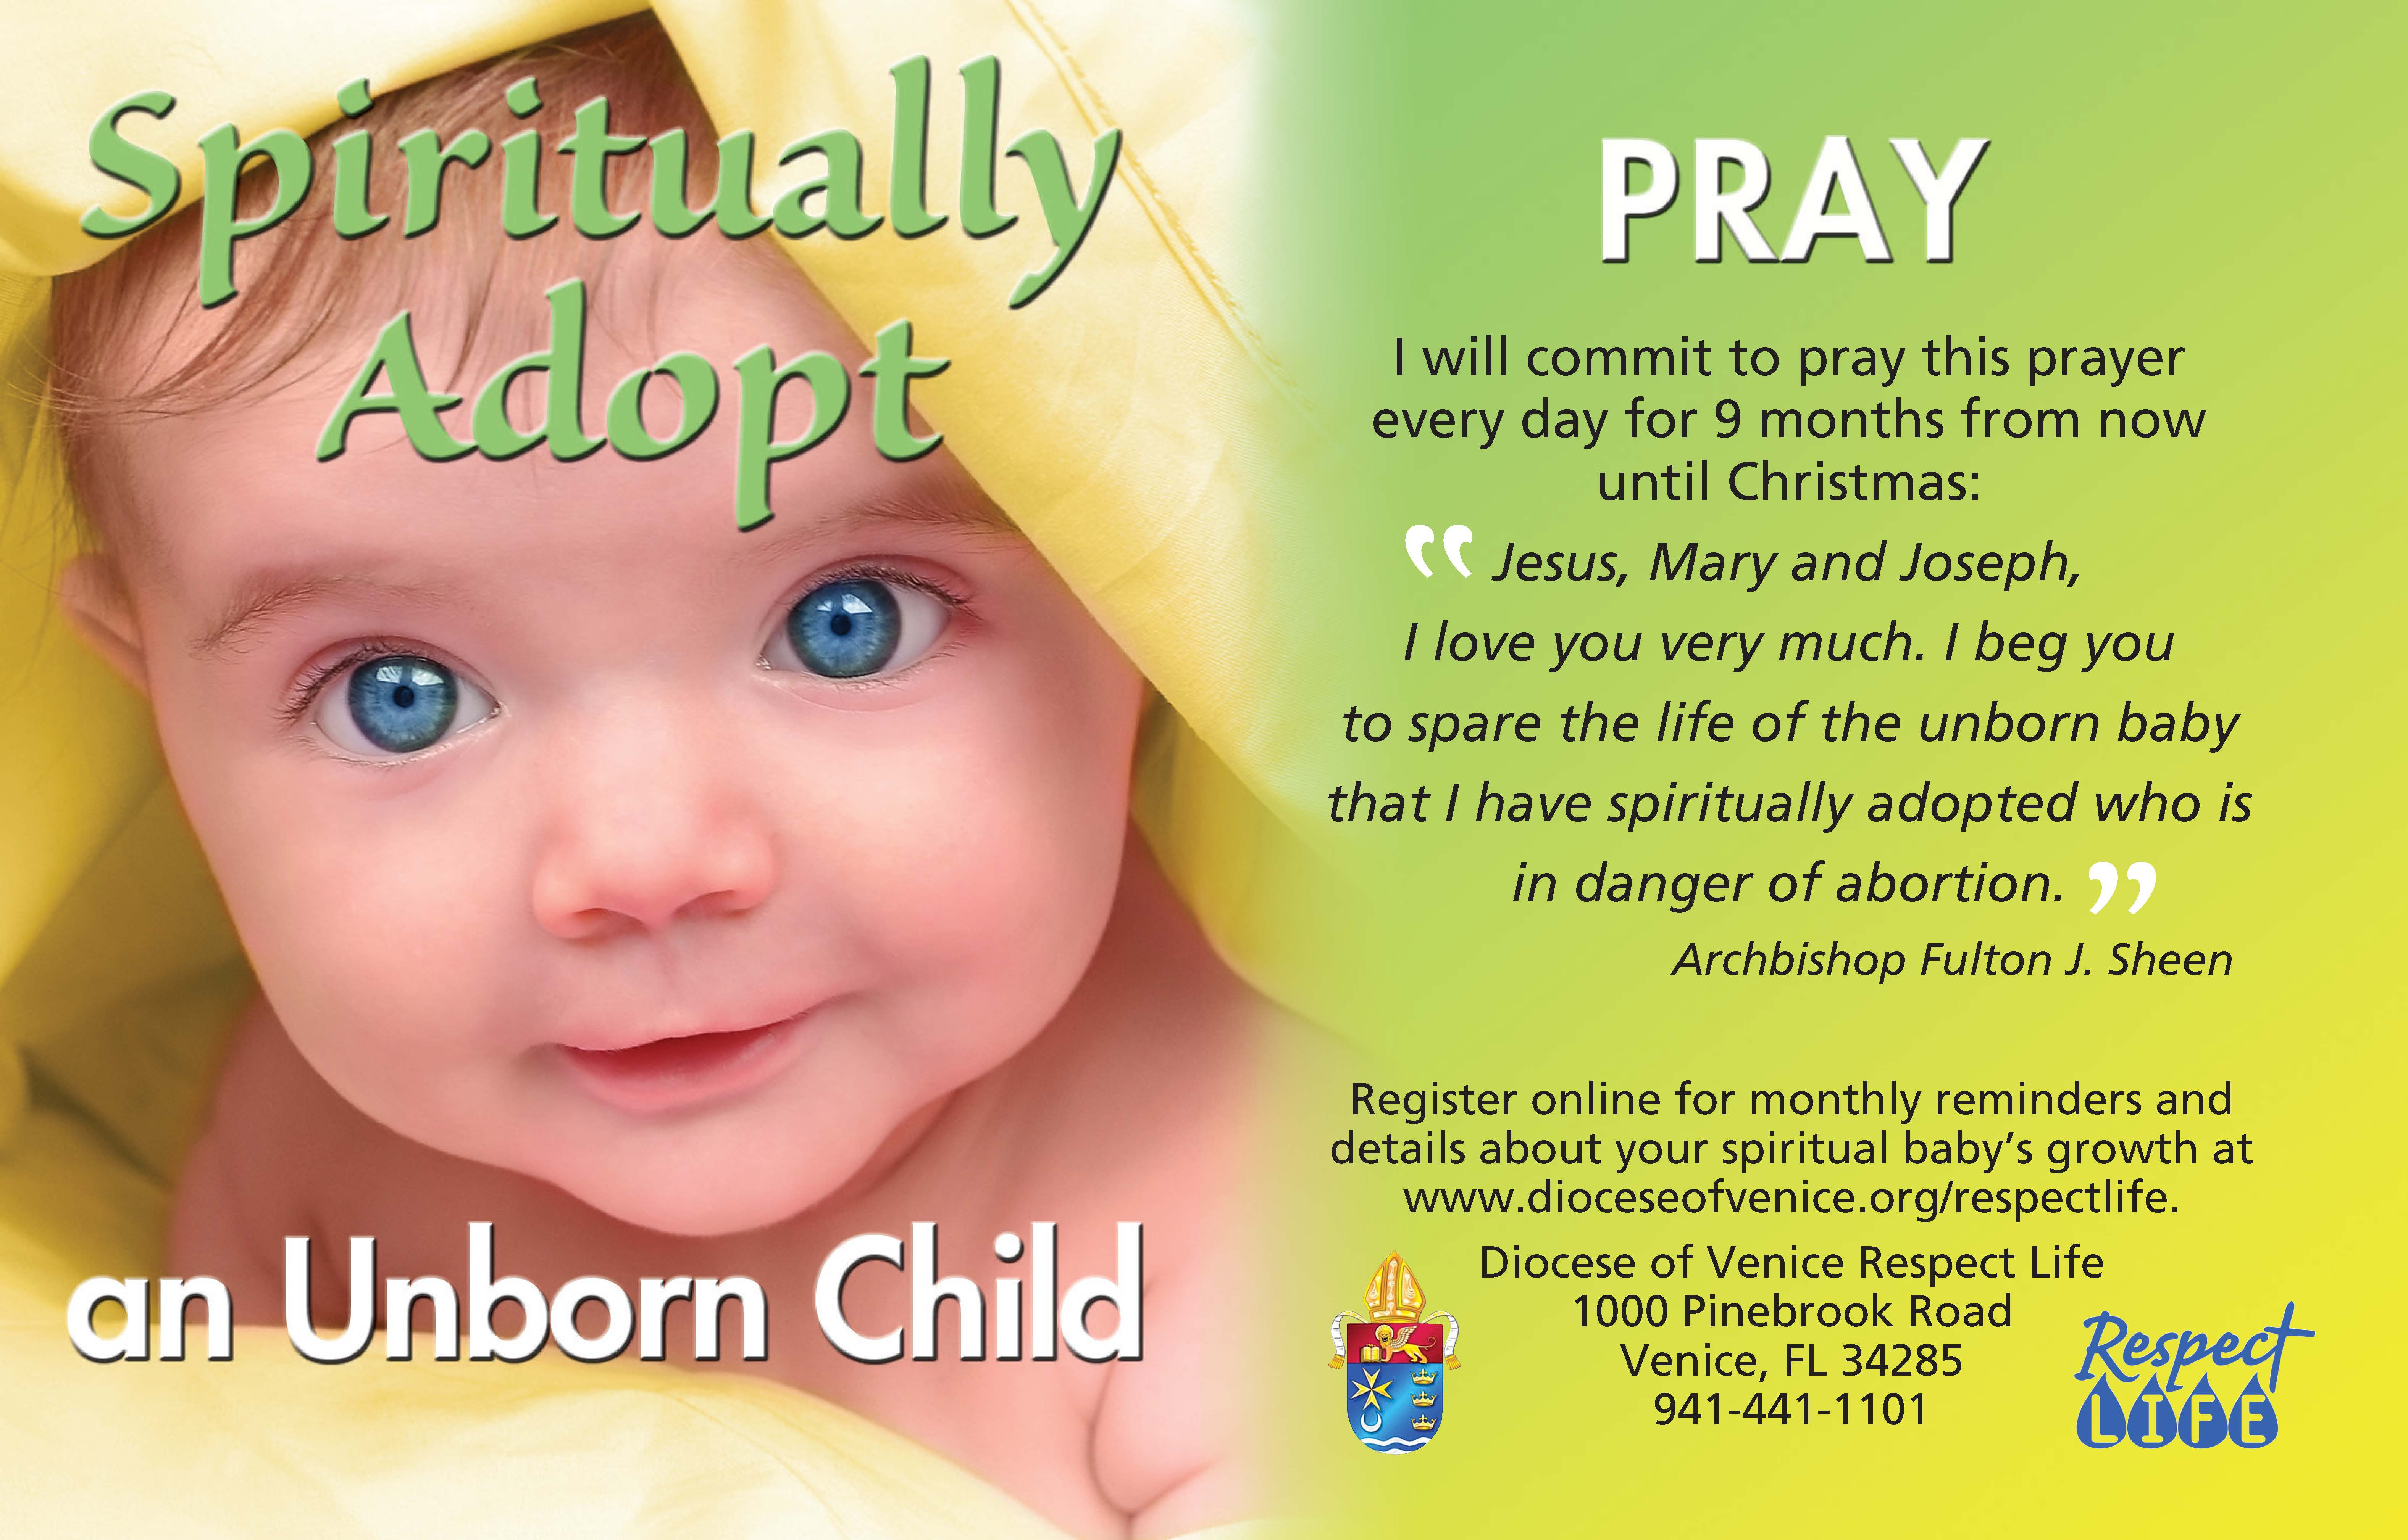
St. Anthony Spiritual
Adoption Program
Month 9
It’s my Birthday! Thank you so much for all your prayers! Join us today for a baby shower after the Sunday Mass for cake and punch to celebrate! Please help the Womans Enrichment Center by bringing in items, such as large diapers, 18-24 month clothes, or walmart gift cards thru the month of February to place in the crib.

PRAYERS FOR OUR
PARISHIONERS
Pray for the soul of:
Maggie Jordan, Perry O’Keefe (Maria Rowse’s brother), Don Calvin, (Irene Calvin’s husband), Pam McKay (Lud McKay’s wife), Paul Hunt, (Marghe’s father).
Please pray for : Matthew Mazziotti, Cory Bond’s niece Ella, Kathy Brinkman, Charlotte Luaces, (Tina Aloe’s grandbaby), Harriet Stech Sloan (Holly’s mom) , Amber Aiello, Frank Schaffer, Ric Bertsch, Bob Morris, Rick Bohling, Virginia Hastings, David Hastings, (Julie Turner’s mother & brother), Barbara Fodey (Jan Orth’s mom), Margot Ryder (Vayla’s daughter in law), Sandra Lazano, Toni Sasayana, Angie McAlear, Matt Guilfoyle, Anita Bock, Lorraine Reynolds, Ruth McCart, Gene Horne, Dr. John Flynn (Pat Flynn’s brother), Joseph Gallardo & family, Irene Calvin, Lindy & Jeff Haney & Family, Bob Morris, Patty McCurdy, Dawn Lapre, Baby Arabella, Bonnie & Dave Boiani, James Longhurst- (Susan Culbert’s nephew) , James A. Callahan, Wilhelmina Oldfield, Deloris Orender, (all relatives of the McClains), Veronica Trinkle, Rita Culbert, (Bruce Culbert’s mom), Barbara DeCosta, Charley Fagan, (Marianne Campbell’s Aunt), Gregory Lerch, Marissa Lee, Kelly Crowder- (Kathy & Hugh Brackett’s daughter), Sherry Thomas -(Nanci’s sister), Marie Havron, Richard Conway- (Fr. John’s father), Dr. Joseph Aloe Jr., Louis Ciamillo and the Louis & Louise Ciamillo Families, Mary Arp, Lisa Arnold, & Bertha Malonis.
Please pray for: the safety of our marines, soldiers, sailors and airmen, especially: Sean Hastings, Phillip Thomas, John J. Banaghan, Carlos Rodriguez, Christopher , Billy Shaw, Greg Langas, Jeff Longhurst, Nicholas Horton, Josh Adkison, Chris Jones, David Rogers, Anthony Clark Yebba, Edward Bowen, Matthew & Patrick Mills, Michael Waranis, Clayton Cornell, Taylor Biggers, Anthony Difiore, & Donald P. Lozano.
PLEASE LET US KNOW IF A NAME NEEDS TO BE ADDED OR REMOVED FROM THE LIST. We will delete names after 30 days.

****NOTICE****
OUR NEW WEBPAGE IS UP AND RUNNING!
Go to:
www.saintanthonyblueridge.com
You will see the bulletin, Mass times, and coming events. We will be adding more as we get all the different ministries listed with their information and links. Let us know what you think and what you would like to see on the webpage!

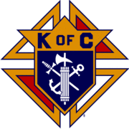
KNIGHTS OF COLUMBUS
Interested in joining the Knights? Please contact a Knight or call Don Wirtz @ 706-258-7696

MASS INTENTIONS
Mon. Feb. 2nd - 9:00am Mass
Eleanor Wilbur-RIP 
Requested by: Hoskings Family
Tues. Feb. 3rd - 9:00am Mass
Maggie Jordan- RIP
Requested by: Clarence & Hanna Stanfield
Wed. Feb. 4th – 9:00am Mass
Maggie Jordan- RIP
Requested by: Deborah Boyer
First Fri. Feb. 6th - 11:00am Mass
Barbara Homer-Sp. Int “Healing for knee surgery” 
Requested by: St. Anthony Parish
Sat. Feb. 7th – 9:00am Mass
Maggie Jordan-RIP
Requested by: Clarence & Hanna Stanfield
Sat. Feb. 7th – 4:00pm Mass
Catherine Ziliak -RIP
Requested by: Doug & Kathy Brinkman

VALENTINES SPAGHETTI DINNER FUNDRAISER!
Saturday, February 14, 2015
4:30-7:30pm downstairs in the Parish Hall
Pasta, Bread, Drink & Dessert
Adults: $8.00 Kids $5.00
Tickets sold in office Monday-Friday after 12:30pm, and after the masses on
Saturday & Sunday.
Funds raised will go to refurbishing the parish hall.

Flowers this week and next week are: In Memory Of:
Peggy Statter
Requested by: Bruce and
Susan Culbert
If you would like to donate flowers In Memory Of or In Honor Of, please call the office

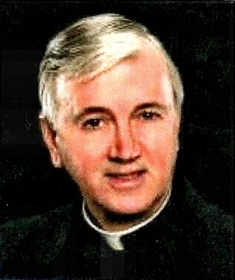
We are excited to have Fr. Albert MacPherson join us again!
Healing Mission Monday, February 9th thru Wednesday, February 11th. Father Albert will be preaching at the Saturday, February 7th, 4:00pm Mass and the Sunday, February 8th, 11:00am Mass. There will be a light luncheon for those that sign up following the Sunday, February 8th Mass, then the opening of the Mission begins at 1:00pm in the church after the luncheon. See the schedule below:

Sunday – 1:00 pm Opening of Mission (Prayer & Supplication)
Monday – 7:00 pm Mass followed by Sacrament of Reconciliation
Tuesday – 7:00 pm Mass followed by Prayer for Healing
Wednesday – 7:00 pm Mass followed by Prayer for Healing

We hope you will mark the dates on your calendar and join us in experiencing God’s healing power working thru Father MacPherson.

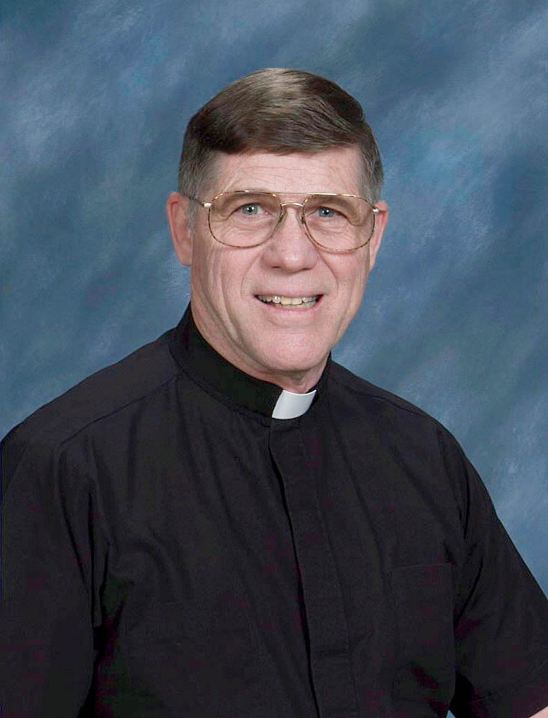
Deacon John Mason will celebrate his 11th year ordination as a Deacon on February 7th.
We will have refreshments celebrating the anniversary of his ordination on Sunday, February 15th after the 11am Mass. Come join us in this celebration for our Deacon!

