Easter Sunday of the
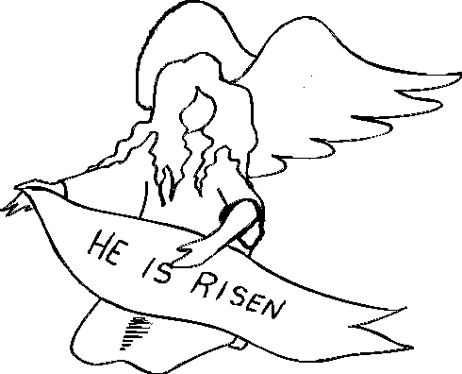
The Lord is truly risen, alleluia. To him be glory and power for all the ages of eternity, alleluia, alleluia. Luke 24:34
Resurrection of the Lord

April 4/5, 2015

USHERS For April

Saturday 7pm – Volunteers
Sunday 8am – Harvey Pinkerton
Sunday 10:30am-Volunteers
Communion Minister to the Sick
April 5, 12 Emily Smith 463-2073
Please inform the Eucharistic Minister of any Catholic who is homebound and wishes to receive the Eucharist.

THE GIFT OF TREASURE
With gratitude for the gifts they have received, parishioners & visitors made a joyful gift of:
WEEKEND of MARCH 28/29, 2015
Holy Family $1,685.92
Smith Valley $697.00
OLPH (Haw.) $665.00

MASS INTENTIONS
April 4th-10th, 2015
SAT 4 7:30 pm +Ken Brown & Family
SUN 5 8:30 am + End of Abortion
10:30am +Joanne Barredo
9:00am SV +Victor Lazzaro
2:00 pm +OLPH
MON 6 +NO MASS
TUE 7 +NO MASS
WED 8 9:00 am +NO MASS
THUR 9 11:00 am +St Anne’s Communion Service
FRI 10 9:00 am +NO MASS



Our Prayer List
Tess Barcellos Mike Lommori
Michael Lackey Guadalupe Olague
Virginia Mantz Alicia Olague
Marty Datenan Edward Seal
Robert Calderon Priscila Wilson
Kayla Cornejo Lilia Madera Zarazua
Kiley Corkern Debbie Tillatson
Jack Pursel Joseph Caughlin
Patty Nicoll Judie Cleary
Ken Bean David Johnson
Nancy Swehla Debbie Varnado Pat Giomi Pat Branson Robert Lindstrand Trisha Benetti
Wendy Matheus Rogers Danny Helgeson
Daniela Cervantes Lorraine Conroy
Joe Cleary Ron Milligan
Patti Carlton Buzzy Deckert
Charles Burr Amanda Borges
Lloyd Giovacchini Eloisa Orozco
Joshua Presley Ray Costa
Dave Aaron Lucille Simpson
Irene Orozco Benavidez Eileen Lopez
Terry Sepsey Beau Roberts
Jo Marriott David Giorgi
Wanda Menesini Ray Carrasco
Olive Pursel Gene Castles
Kimberly Patton Carol Dyhr
Jim Cox Selerino Bovilla Alaniz
Ron Patton Tony Valladao
Joy Laubacher Loren Brown

Celebrate Divine Mercy Sunday with Bishop Randolph Calvo at IMMACULATE CONCEPTION CHURCH on Sun, April 12 at 2:30 p.m., 2900 N. McCarran & Pyramid Blvd. There will be a presentation on the message of Divine Mercy, exposition & benediction of The Blessed Sacrament, The Divine Mercy Chaplet prayer followed by veneration of the Blessed Image of Divine Mercy & a 1st Class Relic of St. Faustina.
Contact Maria Hernandez at 229-0368.



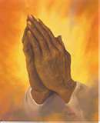
Catholic Services Appeal 2015
We would like to thank all those of you who have made your pledges for the year! Our parish goal is $29,870.66. Anything that goes over our goal will return back to the Parish. CSA is also on the web: www.catholicreno.org.
Families that have pledged: 75
Total Amount Pledged: $23,955.00
Total Cash Received: $17,955.00

*Divine Mercy Sunday, April 12th at St. John’s
2pm Rosary, chaplet & Eucharistic Adoration
3pm Mass
Followed by potluck, please bring a hot dish or salad.
All are invited!

Alleluia! Happy Easter!
We sincerely wish all of you and your family a blessed Easter celebration today and during this Easter season. Jesus is Risen, Alleluia!
Sinceramente les deseamos a todos ustedes y sus familias una Feliz Pascua! Jesus Resucito, Alleluia!

~Father Arias
and Staff of Holy Family~

If you would like to attend the Annual Volunteer Recognition Banquet on April 17th, call the Church office for reservations.

CCD NEWS-Dates to remember
Saturday, April 29th First Reconciliation for First Communion at 6 pm. First Communion will be Saturday, May 9th at 12:30 pm.
Confirmation for 2nd year, Tues, May 26th at 7 pm

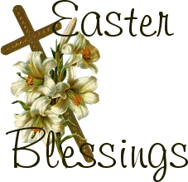

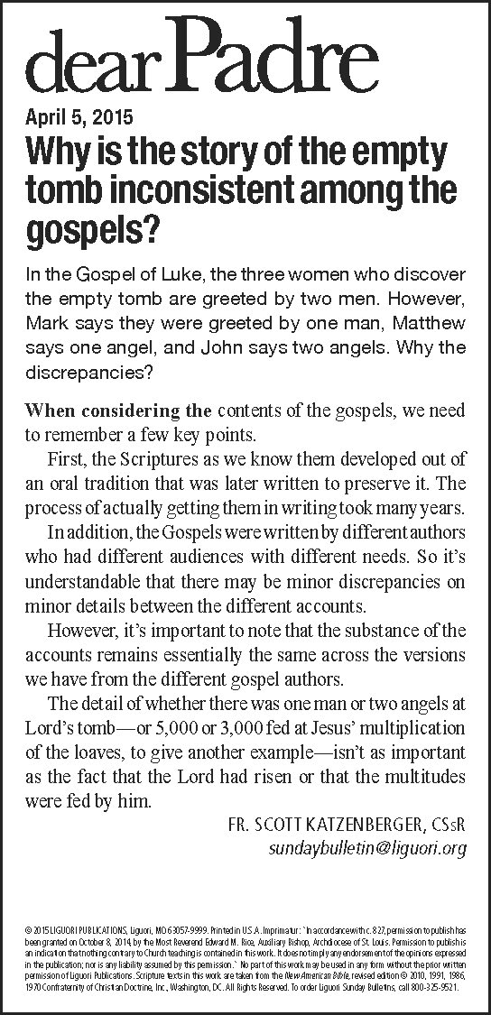

Upcoming Meetings
*Knights of Columbus meeting Wed, April 8th at 7 pm
*St. Anne’s Guild Luncheon/meeting Thurs, April 9th Communion Service at 11:00 am
*The First Crown Meeting for the Portuguese Society will be on Fri, April 10th at 7 pm, at Elsie Brower’s home
*Parish Council meeting Tues, April 14 at 6 pm
*Finance Council meeting on Wed, April 15th at 5pm
*St John’s Advisory Council meeting on Tues, April 22nd at 6pm in Smith Valley
*Knights of Columbus Pancake Breakfast, Sun, April 19th, after 8 am mass
*Italian Catholic’s Dinner Sun, April 19th 5-9 pm

Necesitamos voluntarios que hallan terminado al menos sus estudios de preparatoria en México para ser asesores para aquellos que quieran terminar su primaria y secundaria aqui en Yerington. Favor de llamar al Padre Jorge al 463-2882.

Easter Lilies donated for Prayers for Repose of the Souls of the following loved ones & the anonymous doantions:
Arnold Sciarani from Pauline Sciarani
Rosemarie Ziel from Edward Ziel
Mary Ziel from Edward Ziel
Pam & Jim McKernan from Tom & Kathie Toigo
Bob & Melba Burton from Tom & Kathie Toigo
Gino Toigo from Tom & Kathie Toigo
Lucy Sharkey from Mike & Carol Sharkey
Eileen Owings from Mike & Carol Sharkey
Annie & Tony Masini from Carrol & Maria Masini
Leland & Louise Burr from Dennis & Leah Compston
Henry Koehler from Nancy Koehler
Jack Hannsston from Anna Jean Hansston
The Brown Family from Lita Brown
St Anne’s Guild
Thank you for all the lovely lilies that decorate our church.



This year’s Portuguese Festa will be on June 6th & 7th. The first planning and crown meeting will be at Elsie Brower’s house on Friday, April 10th at 7pm.

Thank you to all who have donated to the parish food bank. During the month of March 2015, your donations have reached 9 needy families.

Sign up today for Camp Joshua & become tomorrow's pro-life leader. Through workshops, games & engaging speakers, you will learn how to change hearts & save lives and will make new friends who believe in life. Sponsored by Nevada Right to Life & the Pro-Life League of Nevada, Camp Joshua will be held May 1-3 at Lake Tahoe. Camp is $75. Scholarships are available.
For more information visit www.CampJoshuaNV.org
or call us at 775-813-4319.

Knights of Columbus will have a Pancake Breakfast
On Sunday, April 19th after the 8 am Mass in the Parish Hall. Donations accepted.

MARK YOUR CALENDAR!
The Knights of Columbus Annual Yard Sale is Sat,
June 20th from 8am-2pm at St. John’s. For
information contact Michael at 220-9364.



HAPPY EASTER!! 

Clase de Ingles
Te gustaria aprender Ingles o mejorar tu Ingles?
La programa de ESL de Norte Nevada va empezar clases el lunes, 6 d.abril. Las clases van hacer cada lunes y miercoles en la tarde, de 7:00 a 8:00 pm en la salon parroquia de la iglesia Holy Family (311 Virginia St). Habra grupos para los principiantes y ostro para los que saben poquito y quieren aaprender mas. Las clases son gratis. Vengan el lunes, 6 d’abril, 2015, para mas informacion, y inviten a sus familias y sus amigos para esta gran oportunidad!
La clase epieza para 6 d’abril 2015. Las clases son gratis!

Spring is here & we need volunteers to help
Clean-up the exterior of the Virginia St House
& prepare it for painting. May 2 & May 16
are scheduled as dates to work.
Come join in the FUN!



