Second Sunday of Lent
Of you my heart has spoken: Seek his face. It is your face, O Lord, that I seek; hide not your face from me. Psalm 27 (26): 8-9


February 28/March 1, 2015

USHERS For March

Saturday 7pm – Volunteers
Sunday 8 am – Volunteers
Sunday 10:30am-Volunteers
Communion Minister to the Sick
March 1 Lita Brown 463-2867
March 8 Anna Jean Hansston 463-5911
Please inform the Eucharistic Minister of any Catholic who is homebound and wishes to receive the Eucharist.

THE GIFT OF TREASURE
With gratitude for the gifts they have received, parishioners & visitors made a joyful return to the Lord:

WEEKEND of February 21/22, 2015
Holy Family $1365.50
Smith Valley $813.00
OLPH (Haw.) $675.00
Central & Eastern Europe $560.11
Ash Wednesday $963.45

Our Prayer List
Tess Barcellos Mike Lommori
Michael Lackey Guadalupe Olague
Virginia Mantz Alicia Olague
Marty Datenan Edward Seal
Robert Calderon Priscila Wilson
Kayla Cornejo Lilia Madera Zarazua
Kiley Corkern Debbie Tillatson
Jack Pursel Joseph Caughlin
Patty Nicoll Judie Cleary
Ken Bean David Johnson
Gonzalo Velasquez Flores Nancy Swehla
Debbie Varnado Pat Giomi
Pat Branson Robert Lindstrand
Trisha Benetti Wendy Matheus Rogers
Daniela Cervantes Danny Helgeson
Joe Cleary Joe Lommori
Patti Carlton Ron Milligan
Stephanie McInnis Charles Burr
Lloyd Giovacchini Amanda Borges
Joshua Presley Eloisa Orozco
Dave Aaron Ray Costa
Irene Orozco Benavidez Lucille Simpson
Terry Sepsey Eileen Lopez
Jo Marriott Beau Roberts
Wanda Menesini Pauline Sciarani
Buzzy Deckert Floyd Justus
David Giorgi Olive Pursel
Ray Carrasco Kimberly Patton
Carol Sharkey Gene Castles
Ron Patton Jim Cox
Selerino Bovilla Alaniz

MASS INTENTIONS
February 28-March 6th, 2015
SAT 28 10:00am +OLPH (Haw)
4:30pm +Henrietta Bunkowski
& Nello Monterastelli
7:00pm +Francesconi Family
SUN 1 8:00am +Rachele Brown
10:30am +Joanne Barredo
MON 2 9:00am +NO MASS
TUE 3 9:00am +NO MASS
WED 4 9:00am +Elaine Obert
THU 5 11:00am +St Anne’s Guild
FRI 6 9:00am +Phyllis Matheus




 LENT SCHEDULE
Stations of the Cross 7 pm
March 6th led by the Portuguese Society
March 13th led by the Hispanic Club (bilingual)
March 20th led by the Italian Catholics
March 27th Interfaith
*Exposition of the Blessed Sacrament*
The Blessed Sacrament will be on exposition every Friday after the 9:00 am mass during Lent

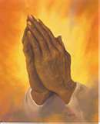

NOTICE:
*Father will be hearing confessions in the church after 9 am mass on Thurs., March 12th

Lenten Reconciliation Service
The Penance Service will be a beautiful experience of God’s grace & forgiveness. Mark your calendar and join us: Wed., March 18th at 6:30pm in the Hall with visiting priests.
Servicio de Reconciliacion Cuaresmal
Acompañanos en una hermosa experiencia de gracia y perdón el miercoles, 18 de Marzo a las
6:30 pm el salon parroquial.

As our prayer list grows, please remember to pray for everyone on the list and their families. Also, please call the office to add or remove names on the prayer list. God Bless you…

Catholic Services Appeal 2015
Another year of CSA has begun. Our parish goal is $29,870.66. All donations that go over our goal will return back to the Parish. Your donation helps fund very important programs and ministries. CSA is also on the web: www.catholicreno.org. Pledge cards are in the back of the church so please remember to pick it up. You may turn it in to the Parish Office or put it in the collection basket. Thank you!

Nominate a Volunteer
The 2015 Diocesan Recognition Banquet, honoring those who give so much to our parishes – our volunteers – will be held on Friday, April 17th. To nominate a truly deserving volunteer or to attend the banquet, contact the office for more information. Nominations due March 19th.

If you would like to be a greeter please contact Basil Quilici at 463-2624.

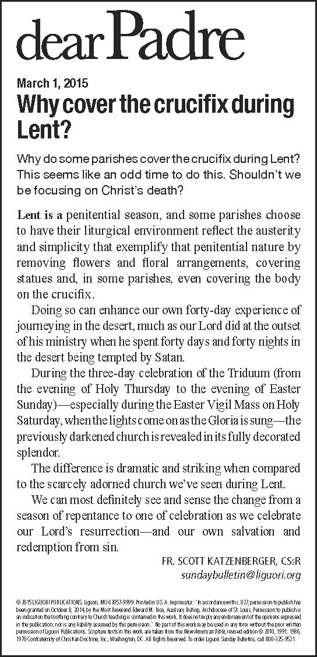

Hungering for a Bountiful Earth
This week CRS Rice Bowl takes us to the coffee highlands of Nicaragua, where we’re called to protect both the goodness of creation and the livelihoods of struggling families. How will this week’s fast remind us of the sacredness of God’s creation and our duty to protect it?

Hambre de una tierra abundante
Esta semana Plato de Arroz de CRS nos lleva a las tierras altas de café de Nicaragua, donde somos llamados para proteger tanto el bien de la creación como los medios de las familias que luchan. ¿Cómo nos recordará el ayuno de esta semana lo sagrado de la creación de Dios y nuestro deber de protegerlo?



Necesitamos voluntarios que hallan terminado al menos sus estudios de preparatoria en México para ser asesores para aquellos que quieran terminar su primaria y secundaria aqui en Yerington. Favor de llamar al Padre Jorge al 463-2882.

Our food pantry is in need of non-perishable food. We are in need of soups, fruits, vegetables, cereal, peanut butter, jelly, boxed side dishes, and juice. Please drop-off your donation at the office.



If you have NOT done so, please call the office
to register any keys that you may have & what
group uses them.
Si no lo ha hecho, por favor llame a la oficina
para registrar cualquier claves que usted
puede tener y qué grupo los usa.



IMPORTANT REMINDER NOTICE
From the Pastoral Council and Finance Committee
Please remember that all Church donations for sacraments (weddings, funerals, baptisms, etc.) & related Church events (Quinceañeras & other activities) are to be paid at the Church office. A receipt will be provided to you for tax purposes. The money will then be deposited into the proper Church fund by the office manager. This would be greatly appreciated & would assist us in our accounting procedures. If you have questions, please call the Church office.

The next Worldwide Marriage Encounter Weekend will be April 17-19 in Sparks, NV. For more information contact Terry or Janet at (916) 489-3464 or visit the website at: http://www.sacramentowwme.org.
This is a great way to enhance your relationship
& enjoy a weekend together.

The CCD 5th & 6th grade will serve coffee & donuts after the morning masses on March 8th. Donations will benefit the Baby Welcoming Committee.


Please support the Knights of Columbus & purchase a raffle ticket for the 60th Annual Seminary
Education Fund. Tickets are $1.00 each &
can be purchased from the Knights or
from the Office. First prize is $1,000 cash!
Purchase your tickets today!

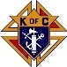


MARK YOUR CALENDARS
*Sun, March 1st at 2 pm, BINGO in the Church Hall
¡ BINGO! Domingo, 1 de marzo a las 14:00 en el centro católico*
*Tues, March 10 at 5 pm, Finance Committee meeting in the Office Conference Room*
*St. John's First Friday Eucharistic Adoration on March 6th will be from 2:00 to 5:30pm.
*Wed, March 11 at 6 pm, Parish Council meeting in the Office Conference Room*
*Wed, March 11, 7 pm, Knights of Columbus meeting in the Catholic Center*
*Tues, March 17 at 6 pm St. John’s Advisory Board
*Thurs, March 19 at 10 am, Mass at Mason Valley Residence
*Sun, March 22 at 5 pm, Italian Catholic’s dinner

ST PATRICK’S DAY DINNER
Mark your calendar for Sunday, March 15th. Adults $17.50, children under 12 $10.00. Cocktails at 5 pm, dinner at 6 pm. Buy tickets after 7 pm or 8 am mass, at the office or at the door.

