
23ST. MARY OF MT. CARMEL
ST. MARY OF MT. CARMEL

SACRAMENTAL PREPARATION
SACRAMENT OF BAPTISM: Parents should be registered and participating members of the parish. Please contact the Rectory during the sixth month of pregnancy to schedule for a parent preparation program, which is held the first Wednesday of each month in the St. Patrick's Room at 7 PM. Baptisms are scheduled the Second and Fourth Sundays of each month at 1:15 PM.

SACRAMENT OF RECONCILIATION:
Saturdays 3:15 PM—4:00 PM at St. Mary of Mt. Carmel, before or after daily Mass, or any time upon request. Parish Family Penance Service: Scheduled Advent and Lent.

SACRAMENT OF MATRIMONY:
Diocesan regulations require that arrangements should be made one year in advance with the officiating Priest. Those desiring to receive this Sacrament must be registered for at least six months and be participating members of St. Mary of Mt. Carmel Parish. As you contemplate marriage, contact the Rectory.
++++++++++++++++++++++++++++++++++
PARISH REGISTRATION
St. Mary of Mt. Carmel Parish Welcomes All

(You can register online. Website address on cover of bulletin)

No matter what your present status in the Catholic Church, no matter what your current family or marital situation; no matter what your past or present religious affiliation; no matter what your personal history, age, background, race, etc.; you are Invited, Welcomed, Accepted, Loved and Respected at St. Mary of Mt. Carmel Parish.
-----------------------------------------------------------
Parish Registration
(Please drop in collection basket)
Name: _____________________________
Address: ___________________________
City: _____________________ Zip ______
Phone: Home: ______________________
Daytime: ___________________________

( ) New Parishioner ( ) Address Change

SACRAMENT OF BAPTISM (SPANISH):
Spanish Baptisms are held the First and Third Sundays of each month at 1:15 PM. Please contact the Parish Office 704-5945 on Tuesdays to schedule. Preparación para el bautismo cada 1er miércoles mensualmente después de la misa de las 7 pm.

SACRAMENT OF ANNOINTING: (Care of Infirm and Elderly): The Rectory may be called at any time for the Sacrament of the Sick. (609-704-5945)

R.C.I.A.: (Rite of Christian Initiation for Adults): For information about RCIA, please contact the Rectory.

SOCIAL CONCERNS / ST. VINCENT
DEPAUL FOOD PANTRY: Food distribution every Thursday 2:30 PM to 4:00 PM and in the evening from 7:00 PM to 9:00 PM in St. Lucy Hall (Convent Basement, French St.).

ADORATION—FIRST FRIDAY OF THE MONTH FOLLOWING THE 8:00 AM MASS UNTIL 4:00 PM BENEDICTION. SIGN UP SHEETS IN VESTIBULE OF CHURCH.
+++++++++++++++++++++++++++++++++++
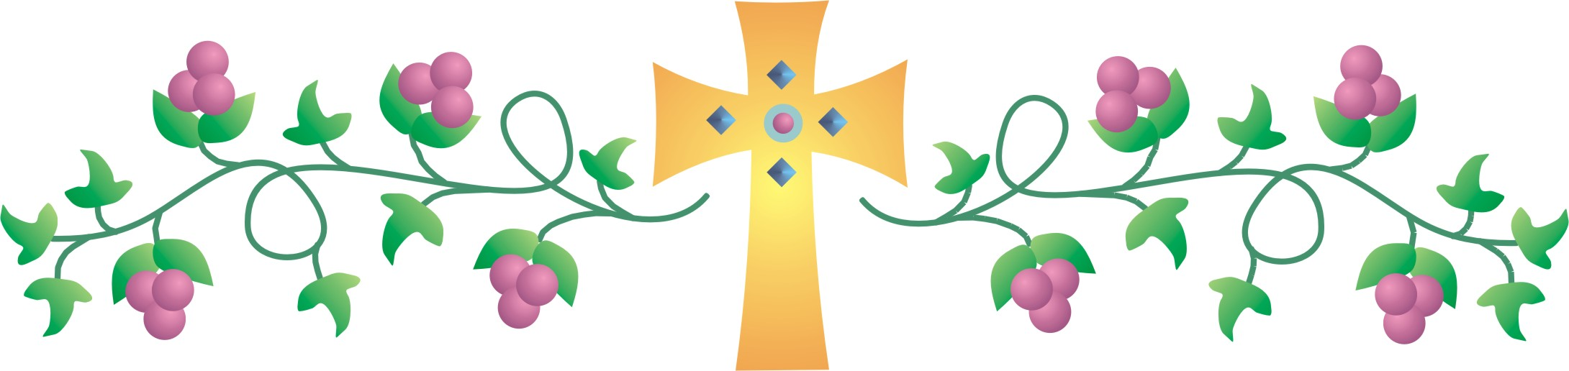

Readings for the Week

Second Sunday in Ordinary Time

Sunday
1 Sm 3:3b-10, 19; 1 Cor 6:13c-15a, 17-20; Jn 1:35-42
Monday
Heb 5:1-10; Mk 2:18-22
Tuesday
Heb 6:10-20; Mk 2:23-28
Wednesday
Heb 7:1-3, 15-17; Mk 3:1-6
Thursday
Heb 7:25—8:6; Mk 3:7-12
Friday
Heb 8:6-13; Mk 3:13-19
Saturday
Heb 9:2-3, 11-14; Mk 3:20-21

SAT 1/17
8:30 am (SJ) Perpetual Mass Remembrance
4:15 pm (SJ) Josephine Mascioli
Req by Ann & Sal Mascola
5:15 pm (SA) Rudy Liberto
Req by Bill & Lorraine Cappuccio
John Crescenzo
Req by Bill Doberstein
Gloria Ordille
Req by Joe & Marti
Frances Cessato
Req by Bill & Lorraine Cappuccio

SUN 1/18
7:30 am (SA) Frances Cessato
Req by Bob & Linda Frankenfield
8:30 am (SJ) Elizabeth Macrie
Req by Barberio Family
10:15 am (SJ) Dec. members Ben & Domenica
Mento Family
Req by Costa Family
Mary Ann Scordo
Req by Elaine Fisher
Elizabeth Macrie
Req by Anna Battaglia
Leon Marino
Req by John Siligato
11:45 am (SJ) Perpetual Mass Remembrance
6:00 pm (SA) Edwin Coia
Req by Mary Ann Adamucci

MON 1/19
7:00 am (SJ) Chris Smith
Req by Sherry Loving
8:00 am (SJ) Antonio & Jenny Tomasello
Req by A. J. Mino
Susan M. Iuliano
Req by Vince Amoroso
Steven Jurasits, Sr
Req by Pat & Anthony Berenato

TUES 1/20
7:00 am (SJ) Terry Tomasello
Req by Rose Prestopino
8:00 am (SJ) Joseph Criscillo
Req by Daughter Pat

WED 1/21
7:00 am (SJ) Zayda U. Barrientos
Req by Barrientos Family

WED (Cont’d)
8:00 am (SJ) Herb Caruso
Req by Noto Family
7:00 pm (SJ) Perpetual Mass Remembrance

THURS 1/22
7:00 am (SJ) St. Vincent Pallotti
Req by Nick Fognano
8:00 am (SJ) Rita Measley
Req by John Donio

FRI 1/23
7:00 am (SJ) Stephen Faust
Req by Lisanne & Greg
8:00 am (SJ) Bertha Damiano
Req by Dana Knights

SAT 1/24
8:30 am (SJ) Charlene Brumbach
Req by Sandra and Jack
4:15 pm (SJ) Perpetual Mass Remembrance
5:15 pm (SA) Michael DeLaurentis
Req by Barbara
Frances Cessato
Req by Charlotte Cessato
Terry Tomasello
Req by John & Kay Tomasello
John Panarello
Req by Aunt Anna Capelli & Family

SUN 1/25
7:30 am (SA) Carmen J. Penza
Req by Family
8:30 am (SJ) Domenica & Giovanni Scianni
Req by Frank & Nancy Scianni
10:15 am (SJ) Elizabeth Macrie
Req by Joanne & John Wiessner
Robert Pearson Sr
Req by John & Nancy Bagliani & Family
Terry Tomasello
Req by Anna Marie Calascione
Parents of Mickey & Joan Perna
Req by Mickey & Joan
11:45 am (SJ) Paul Ciarlante
Req by Fred & Blanca Melendez
6:00 pm (SA) Elizabeth Macrie
Req by Judee DeFiccio

2ND SUNDAY IN ORDINARY TIME–JANUARY 18, 2015

–APRIL 13, 2014

- SEPTEMBER 18, 2011

, 2011

Dear Friends:

My first year at Christ the King Seminary was a most tumultuous one. My first and biggest mistake was thinking that it was merely another program of graduate study. It certainly wasn’t. It was much, much more; and it has taken me more than twenty years after ordination to begin to understand that truth. It was as it was called “a program of priestly formation.” This time began the process, which continues to this very day, of forming me, of empowering me in my discernment of God’s call in how best to serve the Church as a priest. Comprised of numerous components, a program of priestly formation consists of theological education, spiritual direction, therapeutic counseling, liturgical practicums—all designed to help me to become the very best priest that I could be. We hear call stories in our readings this Sunday. The young Samuel is called by the Lord to serve him as a prophet. He does not know that it is the Lord who is calling him: he needs to be formed. Eli tells him what to say and his formation commences. In the passage from the Gospel of John, the Baptist points out to his two disciples that Jesus, the Lamb of God, is walking by. They follow Jesus and bring others to him as well. Their formation begins. Paul in his first letter to the Church at Corinth continues to form the faithful by reminding them that from the moment of their Baptism, their bodies were consecrated to the Lord and are thus called to live in such a worthy manner. For all of us, baptized into the death and resurrection of our Lord Jesus Christ (cf. Romans 6:1ff), we are called to continue in our Roman Catholic Christian formation. That means we continue to grow in our faith by celebrating it (Mass) and receiving the Sacraments, by our personal prayer and reflection upon the Word (Sacred Scripture), and by living its challenges. Our help is the Sanctifying Grace we received at Baptism and that dwells within us in the Holy Spirit. Once marked for Christ, we always belong to Christ. We need to be about the task of living for Christ.

With Peace and Joy!

Fr. Tom

Fr. Tom’s telephone number at
St. Anthony is 561-3313.

Please call before 9 PM unless an emergency

Estimados amigos:

Mi primer año en Cristo el rey seminario era uno más tumultuoso. Mi primer y más grande error fue pensar que era simplemente otro programa de estudios de posgrado. Ciertamente no fue. Era mucho, mucho más; y me ha llevado más de veinte años después de la ordenación para comenzar a entender esa verdad. Era como se llamaba "un programa de formación sacerdotal". Esta vez comenzó el proceso, que continúa hasta nuestros días, de la formación de me empoderamiento en mi discernimiento del llamado de Dios en la mejor manera de servir a la iglesia como sacerdote. Compuesta por numerosos componentes, un programa de formación sacerdotal consiste en la educación teológica, dirección espiritual, consejería terapéutica, prácticas litúrgicas — todos ellos diseñados para ayudar a convertirme en el mejor sacerdote que pudiera ser. Escuchamos historias de llamada en nuestras lecturas de este el domingo. El joven Samuel es llamado por el señor para servirle a él como un profeta. No sabe que es el Señor quien lo llama: tiene que ser formado. Eli le dice qué decir y comienza su formación. En el pasaje del Evangelio de Juan, el Bautista señala a sus dos discípulos que Jesús, el cordero de Dios, está caminando por. Que seguir a Jesús y traen a otros a él también. Comienza su formación. Paul en su primera carta a la iglesia en Corinto continúa para formar los fieles recordándoles que desde el momento de su bautismo, sus cuerpos fueron consagrados al señor y son así llamados a vivir de manera digna. Para todos nosotros, bautizados en la muerte y resurrección de nuestro Señor Jesucristo (cf. Romanos 6:1ff), estamos llamados a continuar en nuestra formación cristiana católica romana. Eso significa que seguimos creciendo en nuestra fe por celebrarlo (masa) y recibir los sacramentos, por nuestra oración personal y la reflexión sobre la palabra (sagrada escritura) y viviendo sus desafíos. Nuestra ayuda es la gracia santificante que recibimos en el bautismo y que habita en nosotros en el Espíritu Santo. Una vez marcado por Cristo, siempre pertenecemos a Cristo. Tenemos que ser sobre la tarea de vivir para Cristo.

¡Con paz y alegría!

Padre Tom

Padre Tom Telefono 561-3313


PRAY FOR OUR SICK: Donna Amendolia, James Badagliacco, Rachael Beretta, Catherine Bilyau, Elise Brunda, Kay Bruno, Lee Chappine, Anita Curran, Lee DeNardo, Taylor Hyndman, Frank Ingemi, Charles Kaston, Mary Kryzoruka, Nora Martines, Kristin Miller-Ruttler, Joseph Panepinto, Jr., Phyllis Pastore, Russell Pavesi, Shelly Perna, Larry Priest, Lillian Renzi, Angeles Rodriguez, Franky C. Roman, Sharon Sacco, Anna Marie Santangelo, Elizabeth Savino Roman, Ruben Roman, Cynthia Sims, William Sulllivan, Anna Templeton, Nick Theisen, Robert Torrance, Wilfredo Torres, Luke Trechy, Donna Wolf, Mary Woolson, Deana Zingrone. Please call the Rectory to add a name to our Prayer List and please let Father Tom know if any parishioners are in the hospital. After three months, the names will be removed unless you inform us otherwise.

Moms, Dads and Caregivers of Toddlers: It's going to be a long winter inside! St. Mary of Mt. Carmel will be hosting a weekday program called God's Little Angels (ages 18 months to 4 years old) in the new year. Bring your little angels for a morning of songs, movement, Bible stories, crafts, introduction to prayers and fun! Beloved retired certified school teachers will be teaching the program with the help from some creative parents of the parish. This is a free program for toddlers and their caregivers. If interested, please leave your name and number with the Parish Center. Starting Wednesday February 4th, 10:30 am in St. Antony Hall.


SCHOOL NEWS
St. Joseph Regional Elementary School will be having Open House and tours for those interested in registering their child or children for all grades, Pre-K 3 through 8th Grade, on Sunday, January 25, 2015, 2pm to 4pm. For more information, please contact the Advancement Director, Susan Sigloch at (609) 704-2400 ext. 104 or by e-mail at ssigloch@stjosephprek8.org.

ST. JOSEPH ELEMENTARY SCHOOL

Please help St. Joseph Elementary School for a chance to win $100,000.00 playground and a chance for your family to win $10,000.00. All you have to do is register on Schoolstore.com. The more people who register the greater chance we all have to win.

SAVE THE DATE! Our 2nd Annual Winter Wonderland Dance will be held on Saturday, January 24, 2015 at St. Anthony Hall from 7:00 to 11:00 pm. DJ, dancing and good food! For ticket information, call the Parish Center 704-5945. If you can make a dessert, call the Parish Center and leave your name and number.

SANCTUARY CANDLE
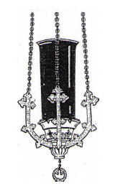

Week of January 18, 2015

St. Joseph Church
In memory of:

Rose Marie Volusher
Req by Pat Criscillo

St. Anthony Church
In memory of: People of the Parish

Chapel of St. Martin dePorres
Sanctuary Light
In Memory of: People of Parish

PLEASE REMEMBER THE DECEASED OF
OF OUR PARISH:

Sue Donio, Scott Henshaw, Andrea Bones, Irene Capoferri, Maria Sassano, Raymond Canfield, William Ebinger, Angelina Tomasello, Helen Renzi


BUSINESS OWNERS – WE NEED YOU!!!

We need your help in placing an ad on the back of our bulletin. There are several sizes and spaces available. The proceeds from these ads make it possible for us to publish our bulletin at no cost and helps provide much needed income to our parish. If you can help by placing a small ad or two, please call Bill Potter at 856-607-3999. We would greatly appreciate it!

PARISHIONERS

When shopping for goods or services or when dining out, please consult the back of our bulletin and patronize those businesses that help support our Parish. Many ads also contain specials, discounts and coupons that will save you money. Let’s all work together for the good of the Parish.

SCRIP CERTIFICATES are available after Masses and at the Parish Center for Bagliani’s, Inferrera’s and Shop Rite. If you need a large order, kindly let the seller know a week ahead or call the Parish Center so that we have an adequate supply on hand for that weekend. The parish receives 5% of the proceeds from the sale of these certificates. Thank you for your participation!

KNIGHTS OF COLUMBUS PADRE PIO COUNCIL meets at St. Martin’s on the second Monday of each month at 7:30 pm.

KNIGHTS OF COLUMBUS
COLLECTION – January 10-11, 2015

1st Collection - $13,026.00
2nd Collection –
Special Needs Heating 3,035.00

1/18/15 SVDP
1/25/15 Mission Membership collection

All donation checks should be made payable to St. Mary of Mt. Carmel, regardless of which worship site you attend (except for St. Vincent de Paul).

Pallotti Council #3471 announces that the 2015 Knights of Columbus Free Throw contest for boys and girls ages 9 through 14 will be held on Sunday January 25 at 11am at St. Joseph High School gym, Central & Vine Sts. The participants are required to furnish proof of age and written parental or guardian consent. All contestants on local level are recognized for their participation in the event, with winners progressing through local, district and state level competitions. For further info, please contact Bill Domenico at 609-287-5237.

YOUTH MINISTRY
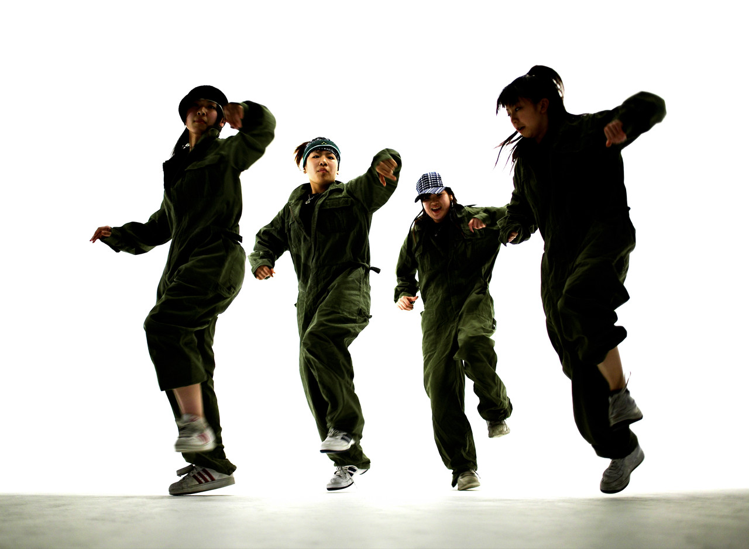
Important things happening with Youth Ministry!

The Junior Youth Group is still having "spiritual guidance" every Tuesday from 2:30 - 4:30, including free pizza and refreshments! It is open to all youth entering 7th through 9th grade, so if your son or daughter falls within this age range, please encourage them to come! It is held in "The Guad" youth lounge, which is located in the parish center (behind St. Joseph's Church).

The next meeting of the Altar Rosary Society will be on Tuesday, January 27, 2015 at St. Joseph Elementary School, Room 204 at 7:00PM.

Bereavement Counseling Session will be held on Wednesday Jan. 21st at St. Anthony of Padua Church at 7 PM in the meeting room. All are welcome to attend. Please use the back door of church for entrance. Any questions please call Debbie at 609 704 5601.

LOST AND FOUND
Two sets of keys have been found in St. Joseph Church and one single diamond earring. Please call the Parish Center at 704-5945.

TAX LETTER
If you are in need of a tax letter, please call the rectory office (704-5945) and leave your name, address and phone number.

LITURGY AND MUSIC NEWS

Here are more opportunities to pray together: Wednesday January 21st; Memorial of St. Agnes, Virgin and Martyr, Thursday, January 22nd; Day of Prayer for the Legal Protection of Unborn Children, Saturday, January 24th; Memorial of Saint Francis de Sales, Bishop and Doctor of the Church and Monday, January 26th; Memorial of Saints Timothy and Titus, Bishops.

We Are Called to Serve: Ministry Sign-Up Weekend is Saturday January 31st and Sunday, February 1st. This is a time to ask the Lord to guide to you a ministry. God blesses us with countless gifts; it is our responsibility to give of ourselves in God's name. There will be sign up sheets available after each Mass. We ask that you fill it out and you will receive information for your chosen ministry.

January is Poverty Awareness Month. In his inaugural homily, Pope Francis said "...amid so much darkness, we need to see the light of hope and to be men and women who bring hope to others."

January 22nd is a Day of Prayer for the Legal Protection of Unborn Children. Please pray for all unborn babies and their mothers.

There is an empty chair waiting for you. Did you notice an empty chair where the Parish Choir sits? That's because we are saving that spot for you! Come and visit us at our rehearsal on Thursdays at 7 p.m. at St. Joseph Church or Lisa Neglia at lisa.neglia@comcast.net.

"Faith has to do with things that are not seen and hope with things that are not at hand" ~ Saint Thomas Aquinas.

Call to Ministry Prayer

Lord God, You alone are the source of every good gift, of the vast array of our universe, and the mystery of each human life.

We praise You and we thank You for Your great power and Your tender faithful love.

Everything we are and everything we have is your gift, and after having created us, you have given us into the keeping of your son, Jesus Christ.

Fill our minds with His truth and our hearts with His love, that in His spirit we may be bonded together in a community of faith, a parish family, a caring people.

In the name and spirit of Jesus, we commit ourselves to be good stewards of the gifts entrusted to us, to share in our time, our talent and our material gifts as an outward sign of the treasure we hold in Jesus. Amen.

THE PARISH OFFICE WILL BE CLOSED ON MONDAY, JANUARY 19 FOR MARTIN LUTHER KING DAY

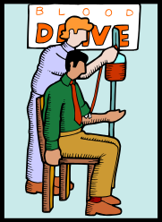
AMERICAN RED CROSS BLOOD DRIVE

Because of a great need for blood, the American Red Cross has asked that our parish host another blood drive in January. Father Donio has graciously agreed to do this.

THE PARISH WILL BE HOSTING A BLOOD DRIVE ON WEDNESDAY, JANUARY 28TH, 2015, FROM 2-7PM.

We are certain that our parish and Hammonton community will respond with the same generosity and concern as you had
for our August Drive! Please be on the look-out for more information, beginning January, 2015. Any questions, please contact Michelle DeFiore, 609-567-8827. All presenting donors this January will receive a voucher for a free poud of Dunkin’ Donuts coffee.

KNIGHTS OF COLUMBUS PALLOTTI COUNCIL 3471 CASINO BUS TRIP Thursday January 22, 2015, departing from the Carnival grounds @5:15pm, $20 trip cost includes bus transportation, $25. Meal voucher good at various Tropicana restaurants plus a $10 slot credit. Please call Steve Cappuccio at 609-377-4489 to reserve your seat.

DIVORCE AND BEYOND- 2/11/2015 to 4/29/2015 at Our Lady of Peace Parish
Divorce and Beyond is for people who are already divorced or have filed for divorce. It helps participants understand what they are going through and that others have gone through the same things. Finally, it suggests activities for making divorce a growth experience.
Registration will take place in the St. Joseph Room at 7:00 PM at Our Lady of Peace Parish, 32 Carroll Ave, Williamstown, NJ on February 11, 2015. A fee of $20.00 for the class and book will be collected. Support Group Guidelines will be outlined. Group will end by 9:00 PM each evening
CAP SESSIONS
The Office of Child and Youth Protection is announcing CAP (Child Assault Prevention) sessions. CAP is the safe environment training program for adults who have regular contact with minors. Attendance is required in order to comply with the USCCB’s Charter for the Protection of Children and Young People. The policy of the Diocese of Camden is that adults will attend CAP once every five years.
CAP 1 teaches attendees to recognize child abuse and neglect and how to report to the proper authorities. Adults are taught that children have the right to be safe, strong and free. CAP 1 is for new volunteers and employees.
CAP 2 is called No More Bullies, No More Victims and is a workshop addressing bullying awareness and bullying prevention. Cyber-bullying is also presented.
CAP 3 is called Cyber-Empowerment and is a workshop which promotes adults understanding of cyber activity of youth while teaching them realistic ways to help children keep their own rights and guard the rights of others in the cyber-sphere.
Each presentation is 90 minutes.
Adults who are new employees or volunteers should attend CAP 1 before attending CAP 2 or CAP 3. After five years, adults have the option of attending CAP 1 or 2 again if they prefer.

The following sessions will be offered in January:

CAP Phase 1

Tuesday, January 20, 2015, 7:00pm, Saint Simon Stock, Berlin

Tuesday, January 20, 2015, 1:00pm, Paul VI High School, Haddon Township, Auditorium
Thursday, January 22, 2015, 7:00pm, Saint Mary of Mt. Carmel, Hammonton, St. Anthony Site, Rte. 206
Monday, January 26, 2015, 6:30pm, St. Joseph Pro-Cathedral School, Camden, Auditorium
Thursday, January 29, 2015, 7:00pm, Saint Mary, Cherry Hill, Hall

To attend one of these classes, please call the CAP registration line in the Office of Child and Youth Protection at (856) 583-6165 or email Diane.Diggons@camdendiocese.org to register. Please register at least five days before the session you would like to attend. IN CASE OF INCLEMENT WEATHER, PLEASE CALL THE LOCATION DIRECTLY.

HOLY SEPULCHRE CEMETERY – ALL CHRISTMAS DECORATIONS NEED TO BE REMOVED BY FEBRUARY 1ST.

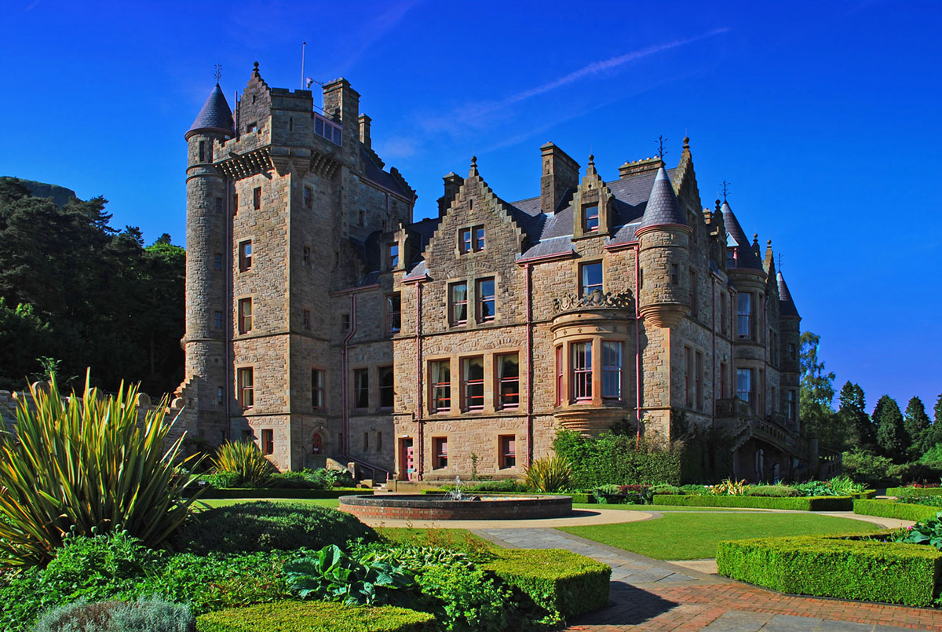
JOIN BISHOP SULLIVAN in IRELAND – July 18 through 29, 2015

Bishop Sullivan is hosting a tour of Ireland departing Philadelphia on Saturday, July 18th and returning to Philadelphia on Wednesday, July 29th. Visit Dublin, Cavan, Armagh, Knock, Galway, the Cliffs of Mohrer, Limerick and much more. Tour includes 11 days/10 nights; ten full Irish breakfasts; ten dinners (one with Irish storytelling and entertainment); gratuities to driver/guide; porterage of one piece of luggage; four star hotels; air conditioned motor coach; and a few Irish ballads sung by the Bishop along the way. The land cost of this tour is $2209 p/p double with a $479 single supplement; space is limited. Airfare costs are based on availability at the time of booking (current estimates are roughly $1300/non-stop). For more information or to register – please contact anna.summers@camdendiocese.org or
Robert.hughes@camdendiocese.org or call 856-583-2807. A non-refundable deposit of $500, p/p is due with registration.



