
23ST. MARY OF MT. CARMEL
ST. MARY OF MT. CARMEL

SACRAMENTAL PREPARATION
SACRAMENT OF BAPTISM: Parents should be registered and participating members of the parish. Please contact the Rectory during the sixth month of pregnancy to schedule for a parent preparation program, which is held the first Wednesday of each month in the St. Patrick's Room at 7 PM. Baptisms are scheduled the Second and Fourth Sundays of each month at 1:15 PM.

SACRAMENT OF RECONCILIATION:
Saturdays 3:15 PM—4:00 PM at St. Mary of Mt. Carmel, before or after daily Mass, or any time upon request. Parish Family Penance Service: Scheduled Advent and Lent.

SACRAMENT OF MATRIMONY:
Diocesan regulations require that arrangements should be made one year in advance with the officiating Priest. Those desiring to receive this Sacrament must be registered for at least six months and be participating members of St. Mary of Mt. Carmel Parish. As you contemplate marriage, contact the Rectory.
++++++++++++++++++++++++++++++++++
PARISH REGISTRATION
St. Mary of Mt. Carmel Parish Welcomes All

(You can register online. Website address on cover of bulletin)

No matter what your present status in the Catholic Church, no matter what your current family or marital situation; no matter what your past or present religious affiliation; no matter what your personal history, age, background, race, etc.; you are Invited, Welcomed, Accepted, Loved and Respected at St. Mary of Mt. Carmel Parish.
-----------------------------------------------------------
Parish Registration
(Please drop in collection basket)
Name: _____________________________
Address: ___________________________
City: _____________________ Zip ______
Phone: Home: ______________________
Daytime: ___________________________

( ) New Parishioner ( ) Address Change

SACRAMENT OF BAPTISM (SPANISH):
Spanish Baptisms are held the First and Third Sundays of each month at 1:15 PM. Please contact the Parish Office 704-5945 on Tuesdays to schedule. Preparación para el bautismo cada 1er miércoles mensualmente después de la misa de las 7 pm.

SACRAMENT OF ANNOINTING: (Care of Infirm and Elderly): The Rectory may be called at any time for the Sacrament of the Sick. (609-704-5945)

R.C.I.A.: (Rite of Christian Initiation for Adults): For information about RCIA, please contact the Rectory.

SOCIAL CONCERNS / ST. VINCENT
DEPAUL FOOD PANTRY: Food distribution every Thursday 2:30 PM to 4:00 PM and in the evening from 7:00 PM to 9:00 PM in St. Lucy Hall (Convent Basement, French St.).

ADORATION—FIRST FRIDAY OF THE MONTH FOLLOWING THE 8:00 AM MASS UNTIL 4:00 PM BENEDICTION. SIGN UP SHEETS IN VESTIBULE OF CHURCH.
+++++++++++++++++++++++++++++++++++


Readings for the Week

Third Sunday in Ordinary Time

Sunday
Jon 3:1-5, 10; 1 Cor 7:29-31; Mk 1:14-20
Monday
2 Tm 1:1-8 or Ti 1:1-5; Mk 3:22-30
Tuesday
Heb 10:1-10; Mk 3:31-35
Wednesday
Heb 10:11-18; Mk 4:1-20
Thursday
Heb 10:19-25; Mk 4:21-25
Friday
Heb 10:32-39; Mk 4:26-34
Saturday
Heb 11:1-2, 8-19; Mk 4:35-41

SAT 1/24
8:30 am (SJ) Charlene Brumbach
Req by Sandra and Jack
4:15 pm (SJ) Perpetual Mass Remembrance
5:15 pm (SA) Michael DeLaurentis
Req by Barbara
Frances Cessato
Req by Charlotte Cessato
Terry Tomasello
Req by John & Kay Tomasello
John Panarello
Req by Aunt Anna Capelli & Family

SUN 1/25
7:30 am (SA) Carmen J. Penza
Req by Family
8:30 am (SJ) Domenica & Giovanni Scianni
Req by Frank & Nancy Scianni
10:15 am (SJ) Elizabeth Macrie
Req by Joanne & John Wiessner
Robert Pearson Sr
Req by John & Nancy Bagliani & Family
Terry Tomasello
Req by Anna Marie Calascione
Parents of Mickey & Joan Perna
Req by Mickey & Joan
11:45 am (SJ) Paul Ciarlante
Req by Fred & Blanca Melendez
6:00 pm (SA) Elizabeth Macrie
Req by Judee DeFiccio

MON 1/26
7:00 am (SJ) Andrew Berenato Sr
Req by Family
8:00 am (SJ) Anne DeLuca (anniversary)
Req by Family
Pat Morgan
Req by Family
Phyllis Witkens
Req by Joe & Rose Marie Monzo

TUES 1/27
7:00 am (SJ) George Parisi
Req by LuAnn Holland
8:00 am (SJ) Robert “Bob” Gibase
Req by Carmella Ammirato

WED 1/28
7:00 am (SJ) William Lista
Req by Jim & Marti Matro

WED (Cont’d)
8:00 am (SJ) Donald Healy
Req by Pete & Barbara Santilli
7:00 pm (SJ) Perpetual Mass Remembrance

THURS 1/29
7:00 am (SJ) Marie Steeb
Req by Donald Ambrose
8:00 am (SJ) Catherine Reeves
Req by Joe & Serene Bartolone

FRI 1/30
7:00 am (SJ) William Loeber
Req by Susan & Russ Taylor
8:00 am (SJ) Grace Littlefield
Req by Marie Mango

SAT 1/31
8:30 am (SJ) Gilda & Michael Ruberton
Req by Family
4:15 pm (SJ) Anthony D. Mento
Req by Annie Arena DiGerolamo
5:15 pm (SA) Frances Cessato
Req by Ron & Elaine Fisher
Elizabeth Macrie
Req by Anthony & Maryann Lucca
Cynthia Young
Req by Marian Silvesti
Shirley Peters
Req by Jenniene Presti

SUN 2/01
7:30 am (SA) Anita Meale
Req by Carl & Dottie Mortellite
8:30 am (SJ) David V. Santoro
Req by David & Darin Santoro
10:15 am (SJ) Perpetual Mass Remembrance
Leon Marino
Req by Americo & Luisa Bruni
Mamie Urgo Petruzzi
Req by Ronnie & Mickey
Catherine Reeves
Req by Robert Lippi
11:45 am (SJ) Marcelo Perez
Req by Blanca Perez & children
6:00 pm (SA) Elizabeth Macrie
Req by Mary Ann Adamucci

3rd SUNDAY IN ORDINARY TIME–JANUARY 25, 2015

–APRIL 13, 2014

- SEPTEMBER 18, 2011

, 2011

Dear Friends:

What does Paul mean by his admonition, “From now on, let those having wives act as not having them, those weeping as not weeping, those rejoicing as not rejoicing…” et al? Paul further emphasizes his point by ending with, “For the world in its present form is passing away.” Time is running out and we must prioritize in order to be ready for the Day of the Lord, that is, the Lord Jesus’ Second Coming. We must not hold on to the things which we think are most important. We must look forward to what awaits us. For us as faithful Roman Catholic Christians that is the Kingdom of Heaven, the Reign of God. As Jesus calls Simon and Andrew, James and John to stop whatever they are doing and follow him, Jesus likewise calls us through Baptism to stop what we have judged is important to us and follow the call and the challenge to love. As the Gospels relate, it is never too late to begin.

We have been having many deaths in our parish family as of late. Last week we had eight funerals. It reminds us how fragile and precious life is and in this week’s second reading how we have to focus on what’s truly important for us. I wish to thank all of you for the outpouring of love and concern that you showed me at the time of my mother’s passing. Mom took up a lot of my time, time which I was most happy to give. She also lived a long and fruitful life. Her example taught me a great deal of what it means to live as part of a community that we call Church. Mom lived her Baptismal call to love in the midst of the Church; and she was one of many in this community, though known by different names throughout the past years, who selflessly gave their love and life. I salute all of you and I thank God for all of you.

With Peace and Joy!

Fr. Tom

Fr. Tom’s telephone number at
St. Anthony is 561-3313.

Please call before 9 PM unless an emergency

Estimados amigos:

¿Qué significa Paul por su amonestación, "de ahora en adelante, dejar que aquellos que tienen esposas actúan como no tener ellos, llorando como no llorando, los gozosos como no regocijándose..." et al. Paul además destaca su punto por terminando con, "para el mundo en su forma actual está pasando lejos." Queda poco tiempo y debemos priorizar con el fin de estar listo para el día del Señor, es decir, venida del Señor Jesús. No debemos mantener las cosas que creemos que son más importantes. Debemos miramos adelante a lo que nos espera. Para nosotros, como fieles cristianos católicos romanos es el Reino de los cielos, el Reino de Dios. Como Jesús llama Simon y Andrew, James y John para detener lo que están haciendo y seguirlo, Jesús además nos llama por medio del bautismo para detener lo que nosotros hemos juzgado es importante para nosotros y seguir la llamada y el desafío de amar. Como los Evangelios se refieren, es nunca es demasiado tarde para comenzar.

Nosotros hemos tenido muchas muertes en nuestra familia parroquial de los últimos tiempos. La semana pasada tuvimos ocho entierros. Recuerda nos lo frágil y es preciosa es la vida y en esta semana de la segunda lectura de cómo tenemos que concentrarnos en lo que es verdaderamente importante para nosotros. Me gustaría dar las gracias a todos ustedes por la efusión de amor y preocupación que me mostraste en el momento del fallecimiento de mi madre. Mamá tomó mucho de mi tiempo, tiempo que estaba más feliz de dar. También vivió una vida larga y fructífera. Su ejemplo me enseñó mucho de lo que significa vivir como parte de una comunidad que llamamos iglesia. Mamá vivió su llamada bautismal de amar en medio de la iglesia; y era uno de muchos en esta comunidad, aunque conocido por diferentes nombres a lo largo de los últimos años, quien desinteresadamente dieron su amor y su vida. Saludo a todos ustedes y gracias a Dios por todos ustedes.

¡Con paz y alegría!

Padre Tom

Padre Tom Telefono 561-3313


PRAY FOR OUR SICK: Donna Amendolia, James Badagliacco, Rachael Beretta, Catherine Bilyau, Elise Brunda, Kay Bruno, Lee Chappine, Anita Curran, Lee DeNardo, Wayne Fucetola, Taylor Hyndman, Frank Ingemi, Charles Kaston, Mary Kryzoruka, Lorna LaMantia, Nora Martines, Kristin Miller-Ruttler, Joseph Panepinto, Jr., Phyllis Pastore, Russell Pavesi, Shelly Perna, Larry Priest, Lillian Renzi, Angeles Rodriguez, Franky C. Roman, Sharon Sacco, Anna Marie Santangelo, Elizabeth Savino Roman, Ruben Roman, Cynthia Sims, William Sulllivan, Anna Templeton, Nick Theisen, Robert Torrance, Wilfredo Torres, Luke Trechy, Donna Wolf, Mary Woolson, Deana Zingrone. Please call the Rectory to add a name to our Prayer List and please let Father Tom know if any parishioners are in the hospital. After three months, the names will be removed unless you inform us otherwise.

Moms, Dads and Caregivers of Toddlers: It's going to be a long winter inside! St. Mary of Mt. Carmel will be hosting a weekday program called God's Little Angels (ages 18 months to 4 years old) in the new year. Bring your little angels for a morning of songs, movement, Bible stories, crafts, introduction to prayers and fun! Beloved retired certified school teachers will be teaching the program with the help from some creative parents of the parish. This is a free program for toddlers and their caregivers. If interested, please leave your name and number with the Parish Center. Starting Wednesday February 4th, 10:30 am in St. Antony Hall.


SCHOOL NEWS
St. Joseph Regional Elementary School will be having Open House and tours for those interested in registering their child or children for all grades, Pre-K 3 through 8th Grade, on Sunday, January 25, 2015, 2pm to 4pm. For more information, please contact the Advancement Director, Susan Sigloch at (609) 704-2400 ext. 104 or by e-mail at ssigloch@stjosephprek8.org.

ST. JOSEPH ELEMENTARY SCHOOL

On January 28th, 2015 from 4pm to 7pm their will be a St. Joseph's Night at the Hammonton McDonalds located on Rt. 30.
Please come out and support our school, all you have to do is when you place your order is just mention St. Joseph Elementary School.

St. Joseph's Elementary School PTA would like to congratulate the winner of our Shore House Raffle, Mrs. Deborah Devlin of St. Mary of Mt. Carmel Parish.

We would also like to send our thanks and appreciation to everyone who purchased tickets for this raffle and made it a success

DECEASED
Warren Noto

SANCTUARY CANDLE
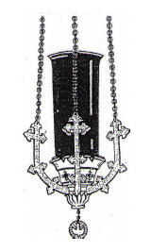

Week of January 25, 2015

St. Joseph Church
In memory of:
Dominic & Millie Zanghi
Req by: Family

St. Anthony Church
In memory of: Dwight McIntosh
Req by: Donald Ambrose

Chapel of St. Martin dePorres
Sanctuary Light
In Memory of: Andrew Berenato Sr
Req by: Family

ST. MARY OF MT CARMEL PARISH
“A THANK YOU”

To Father Tom, the priests and to the members of the congregation who were so kind, helpful and sympathetic after mass Christmas Eve at St. Anthony Church, and all the days that followed.

We will be eternally grateful,
Mel, Rona, Bryan


BUSINESS OWNERS – WE NEED YOU!!!

We need your help in placing an ad on the back of our bulletin. There are several sizes and spaces available. The proceeds from these ads make it possible for us to publish our bulletin at no cost and helps provide much needed income to our parish. If you can help by placing a small ad or two, please call Bill Potter at 856-607-3999. We would greatly appreciate it!

SCRIP CERTIFICATES are available after Masses and at the Parish Center for Bagliani’s, Inferrera’s and Shop Rite. If you need a large order, kindly let the seller know a week ahead or call the Parish Center so that we have an adequate supply on hand for that weekend. The parish receives 5% of the proceeds from the sale of these certificates. Thank you for your participation!

K of C PADRE PIO COUNCIL 14191

- Meets at St Martin’s on 2nd Monday of each month at 7:30 PM

- Co-Hosts Friday Night Bingo at Elm Fire Hall. Kitchen opens at 5PM, games start at 7PM. Come meet an old friend or make a new ones.

- Conducting Essay Contest on “Peer Pressure” for seniors at St. Joseph’s and Hammonton HS. Winning prize is $500 at each school. For details, contact Louise Fourney (St Joe’s) or Lou Testa (Hamm HS)

YOUTH MINISTRY

Important things happening with Youth Ministry!

The Junior Youth Group is still having "spiritual guidance" every Tuesday from 2:30 - 4:30, including free pizza and refreshments! It is open to all youth entering 7th through 9th grade, so if your son or daughter falls within this age range, please encourage them to come! It is held in "The Guad" youth lounge, which is located in the parish center (behind St. Joseph's Church).

CONGRATULATIONS TO ALL THE CHILDREN WHO RECEIVED THE SACRAMENT OF RECONCILIATION LAST WEEKEND. MAY GOD BLESS YOU!
THANK YOU! We are pleased to announce that we reached and surpassed our 2014 House of Charity goal. We collected $91,807 toward our goal of $91,034. As a result, we have received $2,275 back from the Diocese to use in our ministry work here at the parish. I thank all of you for your generosity.

TAX LETTER….If you are in need of a tax letter, please call the rectory office (704-5945) and leave your name, address and phone number.
" WANTED HATS AND GLOVES "
The Ladies Of The Knights of St. Vincent Pallotti Council #3471, with their Knights are collecting
NEW or GENTLY USED hats and gloves. Throughout the month of February, there will be a basket in the front entrance of St. Joseph's and St. Anthony's churches. They will be distributed throughout the community. If anyone is aware of someone in need of these items, they can contact Bonnie Whisler 609-561-8209, our members, or any member of the Knights of Columbus. THANK YOU

 Hospice Volunteers Needed for
Mercer, Burlington, Camden, Monmouth, Ocean and Atlantic Counties!

Hospice of New Jersey enables patients and their loved ones to maximize the Quality of Life. FREE Training is provided to become a hospice volunteer.

Please contact:
Kate Moore, Volunteer Coordinator
856. 488. 2101
Catherine.moore@americanhospice.com
LITURGY AND MUSIC NEWS

Here are more opportunities to pray together: Monday, January 26th; Memorial of Saints Timothy and Titus, Bishops, Wednesday, January 28th; Memorial of Saint Thomas Aquinas, Priest and Doctor of the Church, Saturday, January 31st; Memorial of Saint John (Don) Bosco, Priest and Monday, February 2nd; Feast of the Presentation of the Lord.

We Are Called to Serve: Ministry Sign-Up is next Saturday January 31st and Sunday, February 1st. This is a time to ask the Lord to guide to you a ministry. God blesses us with countless gifts; it is our responsibility to give of ourselves in God's name. There will be sign up sheets available after each Mass. We ask that you fill it out and you will receive information for your chosen ministry.

Have you thought about joining the Parish Choir but just need a nudge? We are a close-knit ministry who enjoys serving the Lord each week from God's altar. You do not need to have a solo voice. If you would like more information, please fill out a Ministry Sign-Up sheet, talk to one of our choir members or contact Lisa Neglia at lisa.neglia@comcast.net .

“Let us strive to fare well in this life and in the next.” John Bosco

Call to Ministry Prayer

Lord God, You alone are the source of every good gift, of the vast array of our universe, and the mystery of each human life.

We praise You and we thank You for Your great power and Your tender faithful love.

Everything we are and everything we have is your gift, and after having created us, you have given us into the keeping of your son, Jesus Christ.

Fill our minds with His truth and our hearts with His love, that in His spirit we may be bonded together in a community of faith, a parish family, a caring people.

In the name and spirit of Jesus, we commit ourselves to be good stewards of the gifts entrusted to us, to share in our time, our talent and our material gifts as an outward sign of the treasure we hold in Jesus. Amen.

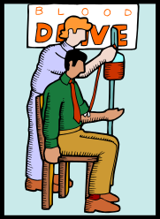
AMERICAN RED CROSS BLOOD DRIVE

Because of a great need for blood, the American Red Cross has asked that our parish host another blood drive in January. Father Donio has graciously agreed to do this.

THE PARISH WILL BE HOSTING A BLOOD DRIVE ON WEDNESDAY, JANUARY 28TH, 2015, FROM 2-7PM.

We are certain that our parish and Hammonton community will respond with the same generosity and concern as you had for our August Drive! Please be on the look-out for more information, beginning January, 2015. Any questions, please contact Michelle DeFiore, 609-567-8827. All presenting donors this January will receive a voucher for a free poud of Dunkin’ Donuts coffee.

SAVE THE DATE!!!!!

The Mater Ecclesiae Dinner Theater will present ~

"NO BODY LIKE JIMMY"

Written by Burton Bumgarner

On Friday, Feb. 13, Saturday, February 14, and Sunday, February 15, 2015 in Bishop DiMarzio Hall, Mater Ecclesiae Church, 261 Cross Keys Road Berlin, New Jersey

(Fri and Sat, Dinner at 6:30 - Curtain at 7:30)
(Sun Matinee: Dinner at 1:30 - Curtain at 2:30)
($23.00 per person - full course dinner & show)

Come and enjoy a superb dinner & a night of laughter! Treat your Valentine to a fun night out! Tickets go on sale Jan. 4 through Feb. 9. For more info or to purchase tickets, contact Kathie DiLoreto at angel.kisses@comcast.net or by calling the rectory office at 856-753-3408. Tickets will not be sold at the door.

DIVORCE AND BEYOND- 2/11/2015 to 4/29/2015 at Our Lady of Peace Parish
Divorce and Beyond is for people who are already divorced or have filed for divorce. It helps participants understand what they are going through and that others have gone through the same things. Finally, it suggests activities for making divorce a growth experience.
Registration will take place in the St. Joseph Room at 7:00 PM at Our Lady of Peace Parish, 32 Carroll Ave, Williamstown, NJ on February 11, 2015. A fee of $20.00 for the class and book will be collected. Support Group Guidelines will be outlined. Group will end by 9:00 PM each evening
CAP SESSIONS
The Office of Child and Youth Protection is announcing CAP (Child Assault Prevention) sessions. CAP is the safe environment training program for adults who have regular contact with minors. Attendance is required in order to comply with the USCCB’s Charter for the Protection of Children and Young People. The policy of the Diocese of Camden is that adults will attend CAP once every five years.
CAP 1 teaches attendees to recognize child abuse and neglect and how to report to the proper authorities. Adults are taught that children have the right to be safe, strong and free. CAP 1 is for new volunteers and employees.
CAP 2 is called No More Bullies, No More Victims and is a workshop addressing bullying awareness and bullying prevention. Cyber-bullying is also presented.
CAP 3 is called Cyber-Empowerment and is a workshop which promotes adults understanding of cyber activity of youth while teaching them realistic ways to help children keep their own rights and guard the rights of others in the cyber-sphere.
Each presentation is 90 minutes.
Adults who are new employees or volunteers should attend CAP 1 before attending CAP 2 or CAP 3. After five years, adults have the option of attending CAP 1 or 2 again if they prefer.

The following sessions will be offered in January:

CAP Phase 1

Monday, January 26, 2015, 6:30pm, St. Joseph Pro-Cathedral School, Camden, Auditorium
Thursday, January 29, 2015, 7:00pm, Saint Mary, Cherry Hill, Hall

To attend one of these classes, please call the CAP registration line in the Office of Child and Youth Protection at (856) 583-6165 or email Diane.Diggons@camdendiocese.org to register. Please register at least five days before the session you would like to attend. IN CASE OF INCLEMENT WEATHER, PLEASE CALL THE LOCATION DIRECTLY.

HOLY SEPULCHRE CEMETERY – ALL CHRISTMAS DECORATIONS NEED TO BE REMOVED BY FEBRUARY 1ST.


JOIN BISHOP SULLIVAN in IRELAND – July 18 through 29, 2015

Bishop Sullivan is hosting a tour of Ireland departing Philadelphia on Saturday, July 18th and returning to Philadelphia on Wednesday, July 29th. Visit Dublin, Cavan, Armagh, Knock, Galway, the Cliffs of Mohrer, Limerick and much more. Tour includes 11 days/10 nights; ten full Irish breakfasts; ten dinners (one with Irish storytelling and entertainment); gratuities to driver/guide; porterage of one piece of luggage; four star hotels; air conditioned motor coach; and a few Irish ballads sung by the Bishop along the way. The land cost of this tour is $2209 p/p double with a $479 single supplement; space is limited. Airfare costs are based on availability at the time of booking (current estimates are roughly $1300/non-stop). For more information or to register – please contact anna.summers@camdendiocese.org or
Robert.hughes@camdendiocese.org or call 856-583-2807. A non-refundable deposit of $500, p/p is due with registration.

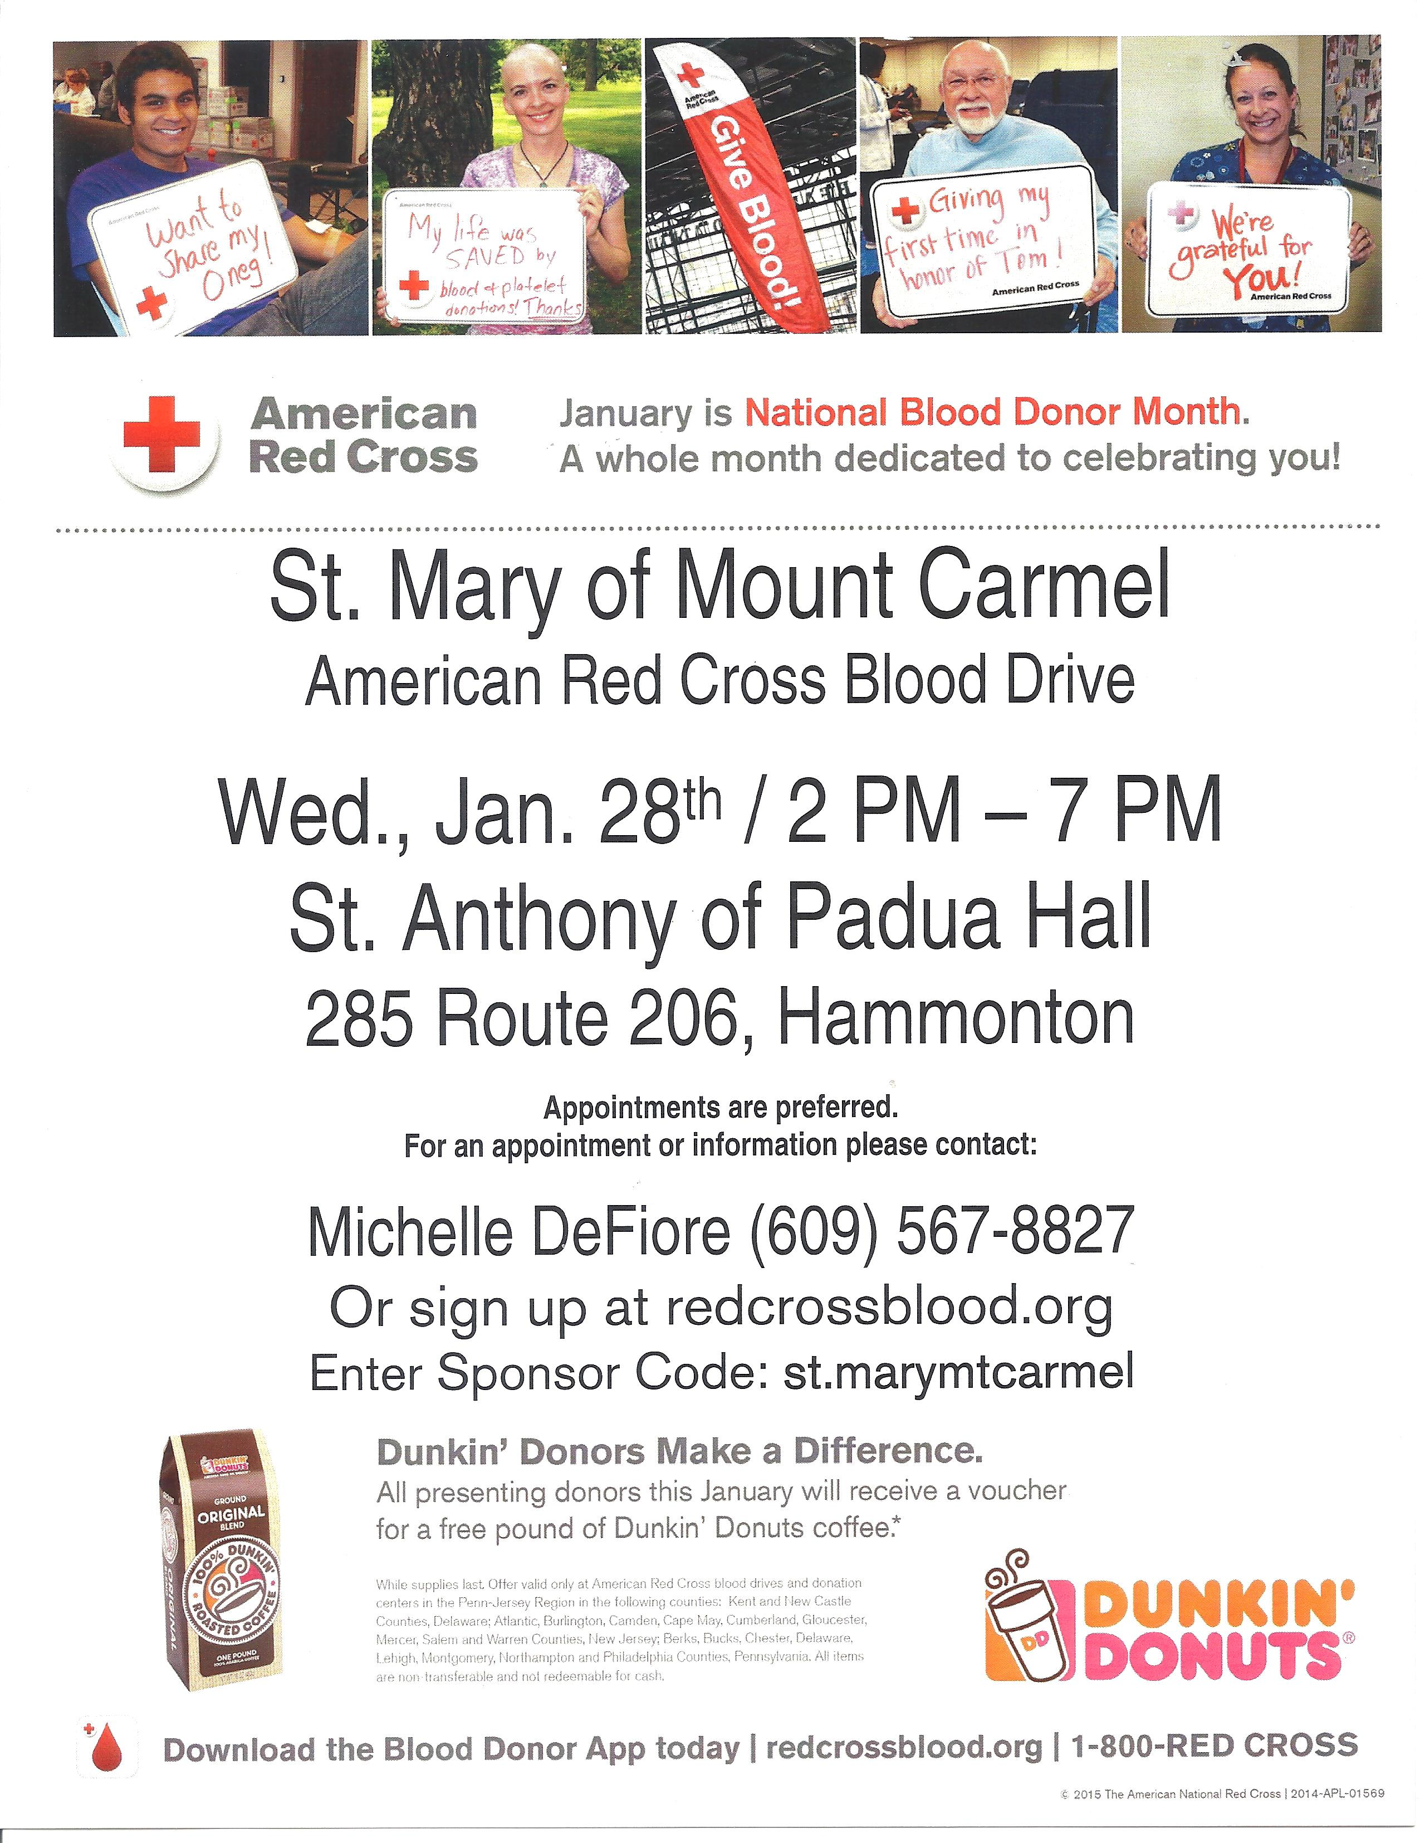


GIVE THE GIFT OF EDUCATION

Be an angel to a student!

As an angel, you enable a student who is at risk financially, to remain at St. Joseph Regional Elementary Catholic School. 100% of your contribution is directed to the tuition, with the parents or guardians contributing their part. Your tax-deductible contributions can be made in honor or in memory of someone you hold dear, while assisting a child who might not otherwise be able to afford the benefit that a Catholic School education offers.

For further information, please contact St. Joseph Regional Elementary School principal, Sr. Betty Jean Takacs, MPF at 609-704-2400 ext 103 or come into the school office or the church office to make a donation.

St. Joseph Regional Elementary Angel Fund

Name ______________________________________________________

Intention _____________________________________________________

Donor _______________________________________________________

Amount _______________________________________________________

