June 14, 2015

11th SUNDAY IN ORDINARY TIME

St. Joseph’s Mass Intentions
Mon. June 15 † John Zuiderveen

Tues June 16 † Gilberto Barajas
Wed June 17 No Mass

Thur. June 18 † Tony Meyer

Fri. June 19 No Mass
Sat. June 20 † Paula Kuehner
Sun. June 21

10:00 a.m. † Don Helmkamp

12:30 p.m. Pro Populo
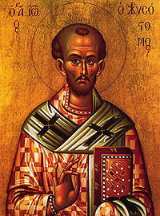

Readings for the week of June 15, 2015

Monday: 2 Cor 6:1-10/Mt 5:38-42
Tuesday: 2 Cor 8:1-9/Mt 5:43-48
Wednesday: 2 Cor 9:6-11/Mt 6:1-6, 16-18
Thursday: 2 Cor 11:1-11/Mt 6:7-15
Friday: 2 Cor 11:18, 21-30/Mt 6:19-23
Saturday: 2 Cor 12:1-10/Mt 6:24-34
Next Sunday: Jb 38:1, 8-11/2 Cor 5:14-17/Mk 4:35-41

St Eutropius
The town of Saintes in south-west France honors as its first bishop St. Eutropius, who was sent from Rome in the third century to evangelize the inhabitants and who suffered martyrdom either at their hands or by order of the Roman authorities. The story locally told is that St. Eutropius accompanied St. Denis to France to share his apostolic labors. The people of Saintes, to whom he preached, expelled him from their city, and he went to live in a cell on a neighboring rock where he gave himself to prayer and to instructing those who would listen. Among others he converted and baptized the Roman governor’s daughter, Eustella. When the girl’s father discovered that she was a Christian, he drove her from his house and charged the butchers of Saintes to slay Eutropius. Eustella found him with his skull split by an axe, and she buried his remains in his cell.

.

Prayer Requests
John Zuiderveen - cancer, Aryanna Shipman, Fred & Theresa Miller- repose, Jimmy McCall & Donnie Closs - cancer, Shirley Gill-surgery, Patrick Grogan Jr.-eyes, Ariana Grandae & Burna Mars.

If you are not registered, please fill out the form below and drop it in the collection basket or mail to the parish office. Si no estan registrados, favor de llenar esta forma y dejarlo en la colecta. Gracias.

Name/ Nombre: _______________________________
Address/ Direccion: _____________________________
City/ Ciudad: ____________Zip/Codigo Postal: _______
Phone/ Tele: ______________________________
Email/Correo electronico: ________________________

__New Parishioner __New Information

__Seasonal Parishioner __Remove from Census

__ Request Envelopes /Sobres?

Contact Persons for Church Ministries
CCD- Brenda Echterling- 463-3393
Eucharistic Mnstrs – Marilyn Morton - 463-7386
Servers - Phil Pritts – 463-3738
Lectors – Delores Henderson- 499-3201
Knights of Columbus – Warren Patka- 562-3061
Communion Visits–Jo Gunthorp- 367-2359

†

Liturgical Ministers Schedule for June

Eucharistic Ministers:
6:00 pm Becky Connelly, Paul Johnston
10:00 am Doug Bowlby, Larry Gephart &
Bobby Johnson
12:30 pm Julio-Elvira y Salvador Nieves
Lectors:
6:00 pm Janet Johnston, Mike Keith
10:00 am Tom Helmkamp
12:30 pm Norma Albor y Maria Anicua
Ushers:
6:00 pm Volunteers
10:00 am Bernard Hoffman, Andrew Stroop
12:30 pm
Servers:
6:00 pm Ruben Hurtado, Phil Pritts
10:00 am Diana Mendoza, Sawyer Shank
12:30 pm Victoria Rodríguez, Leonardo
Munoz Montano

ldo & Nubia Cruz

Grupo de Oración
Cada miércoles del mes (ecepto el primero) tenemos el grupo de oración con cantos de alabanza a las 6 :45 pm en la iglesia. Todos bienvenidos!

Upcoming Events

June 14 Seven Deadly Sins/ 11am
June 14 Corpus Christi Procession 1:45pm

St. Joseph Preschool is now taking registrations for the 2015-2016 school year.
3 & 4 year olds (must be 3 by August 1) class will meet on Tues. and Thurs. 8:30am-11:30am and 12:15pm –3:15pm. The cost for this class is $60 per month and will be limited to 14 students per class. Our 4 & 5 year olds (must be 4 by August 1) will meet on Mon. Wed. & Fri. 8:30am-11:30am and 12:15pm-3:15pm. The cost for this class is $65 per month and will be limited to 16 students per class. If class allows, we will also offer a full day program Mon. Wed. & Fri. 8:30am-3:15pm. The cost for this class is $130.
Children must be potty trained before being enrolled in preschool.

Please contact Tracy Naylor with any questions or to request a registration. Phone 574-612-3828
Our parish will begin the Seven Deadly Sins and Seven Lively Virtues by Fr. Robert Barron on June 14, 2015, after the 10:00 am Mass in the Social Hall. We will continue the same schedule for the 8 weeks of the series. Please join us!

If you have any questions please contact: Ron Denton or Warren Patka.

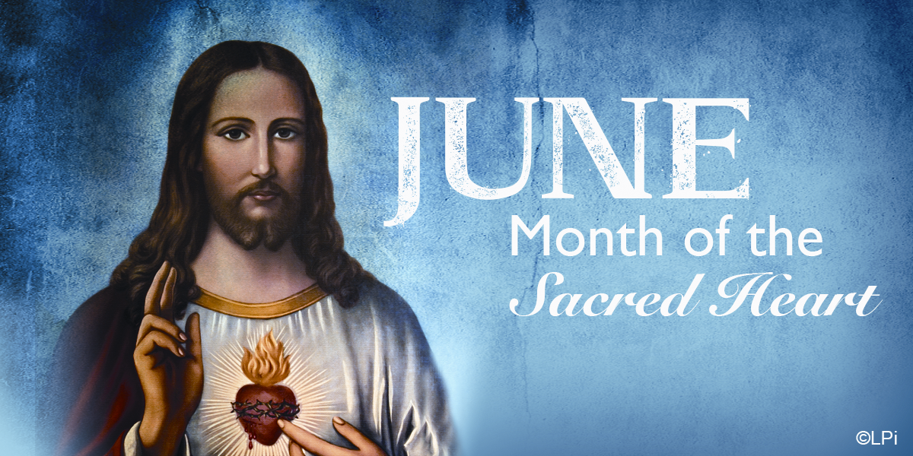

La colecta de la semana pasada: $2,525.00
Fondo de mantenimiento : YTD:$8,031.00
Last week’s regular collection: $2,525.00.
Maintenance Fund YTD: $8,031.00

