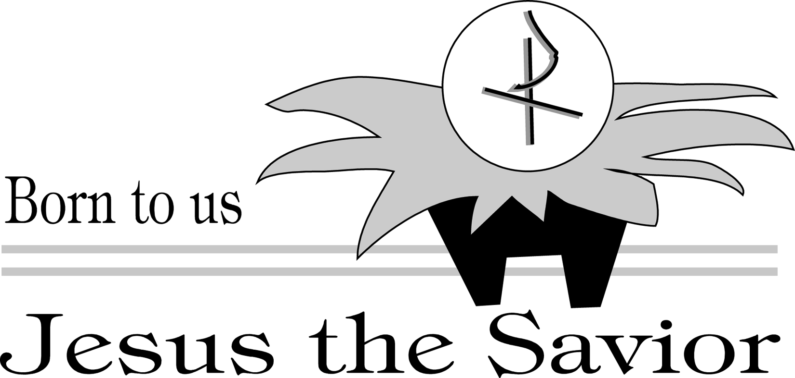

MASS INTENTIONS FOR THE WEEK

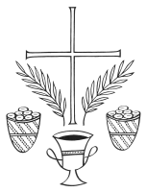

Saturday December 20, 2014
8:00 a.m. | Richard & Anna Ritter
5:30 p.m. | Ramona Rodríguez

Sunday December 21, 2014
SP 8:00 a.m. | Victoria Tovar
10:00 a.m. | Walter Gammer
SP 12:00 p.m. | 25th aniversario de bodas  Marcos & Ivy Ramos

Monday December 22, 2014
7:00 a.m. | Adolph & Anna Wind
12:05 p.m. | David & Anna Amparo

Tuesday December 23, 2014
7:00 a.m. | Victoria Tovar
12:05 p.m. | Seamus Dingby

Wednesday December 24, 2014
5:30 p.m. | Parishioners and Friends
9:00 p.m. | Parishioners and Friends

Thursday December 25, 2014
10:00 a.m. | Christmas Intentions
12:00p.m. | Christmas Intentions

Friday December 26, 2014
12:05 p.m. | Francis Novak

Saturday December 27, 2014
8:00 a.m. | Dominic Sendi
5:30 p.m. | Jose Antonio Matamoro

Sunday December 28, 2014
SP 8:00 a.m. | Toma Then & Carmen Cordova
10:00 a.m. | Domenick & Louisa Santilli
SP 12:00 p.m. | Lidia Ramirez

WEEK OF DECEMBER 21, 2014
Sunday
2 Sm 7:1-5, 8b-12, 14a, 16; Rom 16:25-27; Lk 1:26-38
Monday
1 Sm 1:24-28; Lk 1:46-56
Tuesday
Mal 3:1-4, 23-24; Lk 1:57-66
Wednesday
2 Sm 7:1-5, 8b-12, 14a, 16; Lk 1:67-79
Thursday
Vigil: Is 62:1-5; Acts 13:16-17, 22-25; Mt 1:1-25 or 1:18-25
Night: Is 9:1-6; Ti 2:11-14; Lk 2:1-14
Day: Is 52:7-10; Heb 1:1-6; Jn 1:1-18 or 1:1-5, 9-14
Friday
Acts 6:8-10, 7:54-59; Mt 10:17-22
Saturday
1 Jn 1:1-4; Jn 20:1a, 2-8
Sunday
Sir 3:2-6, 12-14 or Gn 15:1-6, 21:1-3; Col 3:12-21 or 3:12-17 or
Hb 11:8, 11-12, 17-19; Lk 2:22-40 or 2:22, 39-40

SACRED HEART
2013-2014 Weekly Budgeted Amount: $6,914.00
DECEMBER 14, 2014

PLATE: $4,463.30
CURRENT PROJECTS: $175.00
WEEKLY DEFICIT: (-$2,275.70)
YEAR TO DATE BUDGETED: $165,936.00
YEAR TO DATE DEFICIT: (-43,790.94)

CLEANING MINISTRY



Thanks to the Juan XXIII crew who cleaned the church this weekend. The Charismatic Group group is in charge next week. God Bless them!

MINISTERIO DE LIMPIEZA

Gracias al grupo de Juan XXIII, quienes limpiaron la iglesia este fin de semana.
El grupo de la Renovación Carismática es responsable por el próximo sábado. ¡Que Dios los bendiga!
THE SICK/LOS ENFERNOS  Please call the rectory office with names of any parish members who are sick and need prayers.  SO WE CAN ALL PRAY FOR THEM. | 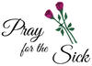

Clara Bellizi | Luis Martinez | Israel Gonzalez
Christine Deschler | Dulce Guerrero | Rosalie Montagner
Francisca Alvarado | Andrew Kratzer | Madeline Messina
Mariana Duque | Ralph Abreu | Antonio Rodriquez
John Donio | Carlos De Paula | Charles Trinkle
Amber Rodriquez | Kane Mendez | Sonia Collazo
Carmen Gonzalez | Elizabeth Rosado | Janice Clements
Josephine Miller | Pat McMann | Ramon Zaez
Randy Colangecco | Gertrude Sweeney | Víctor A. Rodríguez
Gisneidy Davis | Patricia Pressman | Carmen Vázquez
Eric Benavidez | Luis A. Santiago | Jean Brigo
Rosa Rivera | Itzamary Medina | Juan Diaz Lopez
Félix Tiburcio | Jose Pablo Ramos | Natalie Richardson
Santos Solís | Assunta Brunetta | Gloria Yaindl
Lang Pham | Matilde Rosado | Aurora Kundrick
Kenneth Morgan | Jean Moyer | Santiago Godinez
Maria Lantigua | Julio Mora | Aldo Deschler
Norma Martinez | Antonia Maysonet | William Minch
Juan Maldonado | Luz Rendon | Carmelo Narvaez
Willie Watkins | Frances Morrissey | Alaxza Solis
Alondra Nicole Padilla | Freddie Ocacio | Margaret Strasser
Carmelo Hernandez | Jesus Ramos | Emerita Herrera
Vividiana Colon Perez | Vicky Ann Kassis | Joseph Marth
Sharon Stopay | Carmen Marrero | Oscar Santiago
Connie Trach | Margarita Cintron | Josephine Hanisits
Minerva Perez | David Krause

Pray for our Soldiers in Military Service

Juan Lugo | Kyle John Stangl | Stanley Webb, Jr.
Philip L. Cerami, Jr. | Daniel Tone | Luis E. Cevallos
Aaron Fernandez | Carlos Muñoz | Emilio Richardson
Devonna Ortiz | Melvin J. Santiago | Joshua Isley
Steven Lane II | Eric Eichner | Keisha Page
Xavier Vargas | Charlie Alvarez | Tim Forero
Brooke Cully | Steven Narvaez | Bruce Lee Allen
Justin Nieves | Richard Harris | Cristina Sacasa

SCHOOL NEWS
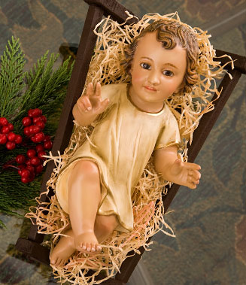

- The Sacred Heart Regional School staff and students would like to thank our parishioners for their spiritual and financial assistance during the Sacred Heart school year. We wish you a Blessed and Happy Christmas.
- Thank you to Vanessa De Jesus and Dr. Whalen from LV Hospital for taking the time to read to our Third Grade class.
- Follow our school on our website at shrschool.org.

THE PASTORS CORNER

CHRISTMAS 2014



Christmas unites and delights. God unites earth to heaven in Jesus. We delight in this newborn hope, as a new and glorious morn has risen from a humble manger in Bethlehem 2000 years ago.

Sacred Heart unites and delights in Fr. Mark Searles first Christmas as a priest. He certainly brings us together with his faith, energy and know-how, from his creation of our Facebook page, to the rededication of Fr. Nerz’s chalice.

While delighting and uniting in Chritsmas 2014, we don’t neglect those people who paved the Christmases past; our parents, family and friends. Our deacons, Fr.

Mark, and myself join to relish all the ways that Monsignor Grabish and Fr. Garcia united and delighted us as a parish family. We unite in missing these two priests this Christmas, and send our prayers to them, as they spread the newborn Good News of Christmas in Reading.

The hope that comes with the birth of our newborn Savior unites and delight us. May Christ’s birth unite

and delight in this time of Christmas, and give us joy and peace. We unite and delight together in Jesus birth, as the parish family of Sacred Heart.

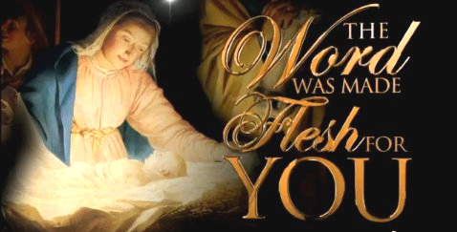

POPE FRANCIS INTENTIONS FOR MONTH OF DECEMBER

Christmas, hope for humanity: That the birth of the Redeemer may bring peace and hope to all people of good will.

Parents: That parents may be true evangelizers, passing on to their children the precious gift of faith.

INTENCIONES DEL PAPA FRANCISCO POR EL MES DE DICIEMBRE

Navidad, esperanza para la humanidad: Que el nacimiento del Redentor traiga la paz y esperanza a todas la personas de buena voluntad.

Padre: Que los padres puedan ser verdaderos evangelizadores, pasando a sus hijos el precioso don de la fe.

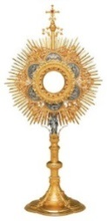
ADORACIÓN PERPETUA

Hora Santa
Primer viernes del mes

Unidos a toda la Iglesia en la Eucaristía
¡Adoremos Al Santísimo Sacramento!
Viernes 2 de Enero del 2015
Desde las 12:45 p.m. hasta las 6:45 p.m.
CAPILLA DEL HIS CENTER



L RINCÓN DEL PÁRROCO

NAVIDAD 2014
La Navidad une y deleita. Dios une la tierra al cielo en Jesús. Nos deleitamos en la esperanza del recienacido, como un nuevo y glorioso amanecer que se ha levantado desde un humilde pesebre en Belén hacen 2000 años.

Sagrado Corazón se une y se deleita en la primera Navidad del Padre Mark Searles como sacerdote. Él ciertamente nos trae junto con su fe, energía y conocimiento; su creación de nuestra página en Facebook, y la reinauguración del cáliz de Fr. Nerz.

Mientras que nos deleitamos y esperamos en la Navidad 2014, no descuidemos quienes sembraron las Navidades pasadas; los padres, familias y amigos.
Nuestros diáconos, el Padre Mark y yo nos unimos para disfrutar de todas las maneras en que el Monseñor Grabish y el Padre García nos unieron y nos deleitaron como familia parroquial. Nos unimos en la falta que nos hacen estos dos sacerdotes en esta Navidad y enviamos nuestras oraciones, mientra ellos extienden la Buena Nueva del recién nacidao durante la Navidad en Reading.
La esperanza que viene con el nacimiento del reciennacido, nuestro Salvador nos une y nos deleita. Que el nacimiento de Cristo nos una y nos deleite en esta época de Navidad, de paz y alegría al continuar juntos como la familia de la Parroquia del Sagrado Corazón.



